Software Requirements Specification

for

Music Medley, Release 1.0

Version 1.0 approved

Prepared by: The Hamilton County Hoosiers (Team 51)

Abigail Hackett, Bennett Dierckman, Emma Smith, Noah Kiser

November 12, 2017

Table of Contents

Table of Contents ii

Revision History ii

1. Introduction 2

**1.1 Purpose 2**

**1.2 Document Conventions 2**

**1.3 Application Vision, Scope and Features 2**

**1.4 References 2**

2. Overall Description 3

**2.1 User Classes and Their Use Cases 3**

**2.2 Operating Environment 3**

**2.3 Design and Implementation Constraints 4**

**2.4 Assumptions and Dependencies 4**

3. Functional Requirements 4

**3.1 Use Cases for Users 4**

**3.2 Use Cases for Hosts 8**

**3.3 Use Cases for Attendees 9**

4. External Interface Requirements 13

**4.1 User Interfaces 13**

**4.2 Hardware Interfaces 14**

**4.3 Software Interfaces 14**

**4.4 Communications Interfaces 14**

5. Other Nonfunctional Requirements 14

**5.1 Performance Requirements 14**

**5.2 Safety Requirements 14**

**5.3 Security Requirements 14**

**5.4 Software Quality Attributes 15**

Appendix A: CRC Cards 15

Appendix B: ERD . 21

**Appendix C: Flow of Activities ……………………………………………………………..... 22**

**Appendix D: Low-Fidelity Mockups …………………………………………………….….... 23**

Revision History

|  |  |  |  |
| --- | --- | --- | --- |
| **Name** | **Date** | **Reason for Changes** | **Version** |
| Bennett Dierckman | 11/2/17 | Added Purpose and formatting | 1.0 Edit 1 |
| Whole Team | 11/2/17 | Added 1.1-1.3 | 1.0 Edit 2 |
| Bennett Dierckman | 11/4/17 | Added 1.4-2.4 | 1.0 Edit 3 |
| Bennett Dierckman | 11/5/17 | Added initial Use Cases to Section 3 | 1.0 Edit 4 |
| Emma Smith | 11/5/17 | Added more to section 3.2 & 3.3 | 1.0 Edit 5 |
| Noah Kiser | 11/7/17 | Added Section 3.2 | 1.0 Edit 6 |
| Bennett Dierckman | 11/7/17 | Added Section 4 | 1.0 Edit 7 |
| Noah Kiser | 11/11/17 | Added Section 5 | 1.0 Edit 8 |
| Bennett Dierckman | 11/11&12/17 | Added Photoshop Sharpened Apendixes Emma’s CRC cards Noah’s ERD  Bennett Flow of Activity Abby’s Mockups | 1.0 Edit 9 |
| Emma Smith | 11/12/17 | Updated Table of Contents | 1.0 Edit 10 |

# Introduction

## Purpose

The purpose of this document is to explain the requirements for the MusicMedley, an Android Application designed to bring the power of democracy to verified users through interactive amendable media playlists.

## Document Conventions

Functional requirements will be organized by user type within Section 2.1.

## Application Vision, Scope, and Features

**1.3.1 Vision Statement**

The MusicMedley Android application aims to provide users with an all-inclusive media consuming experience. It will provide an environment where users are given the power of influencing the playlist through media suggestion and vote of the medias currently populating the playlist.

**1.3.2 Application Scope**

MusicMedley aims to provide a pleasant experience to a variety of users whom enjoy consuming and discussing medias with one another. This demographic will include individuals over the age of 13. For testing purposes, our target demographic will be comprised of individuals between the ages of 18 and 25, due to the application being developed here at Indiana University.

**1.3.3 Application Features**

Depending on whether the user is acting as a Host, Attendee, or Just a user, their feature capabilities will change accordingly. Users acting as a Host will be capable of creating parties and assigning their preferred criteria, including the initial playlist as well as other options. Users acting as Attendees will be capable of discovering nearby parties, joining a selected party upon entering a password, suggesting songs to the playlist, and liking/disliking/loving songs.

## References

Direct Competing Technologies

* <https://en.wikipedia.org/wiki/Turntable.fm>
* <http://www.touchtunes.com/about/overview/>

YouTube API

* <https://developers.google.com/youtube/v3/>
* <https://developers.google.com/youtube/android/player/>

ToutorialsPoint

* Java - <https://www.tutorialspoint.com/java/>
* Android Studios - <http://www.tutorialspoint.com/android/android_studio.htm>

# Overall Description

## User Classes and Their Cases

**2.1.1 User**

A user is anyone whom has downloaded the application from Google Play and has created (or is creating) an account. The user is a parent class and includes features regarding the user’s account, profile, and ability to create and join parties.

Use Cases:

UC-U-1: Create Account

UC-U-2: User Login

UC-U-3: User Logout

UC-U-4: Manage Profile

UC-U-5: Add Friends

UC-U-6: Delete Friends

UC-U-7: View Friends List

UC-U-8: View Recent Parties

UC-U-9: View Advertisement Details

UC-U-10: Turn on Party Discovery Mode

**2.1.2 Host**

Host is a subclass of user. A Host is a user who has created a party has set its specifications to accommodate their unique environment.

Use Cases:

UC-H-1: Create Party

UC-H-2: Display YouTube Video

UC-H-3: End Party

**2.1.3 Attendee**

Attendee is a subclass of user. An Attendee is a user who has turned on Party Discovery mode and has joined and entered the selected party’s password. Having done so, the attendee will be capable of influencing the Party’s playlist via video suggestion and voting on the playlist’s current videos.

Use Cases:

UC-A-1: Join Party

UC-A-2: Suggest Song

UC-A-3: Like Song

UC-A-4: Dislike Song

UC-A-5: Love Song

UC-A-6: View Party Playlist

UC-A-7: Leave Party

## Operating Environment

Music Medley will be created in Android Studios and will therefore require the use of Android as the user’s primary environment. In their engagement with the application (ex, Registering and Logging in) the application will utilize PHP files stored on the Burrow Domain of the soic.indiana.edu Server to communicate sanitized and appropriately encrypted user input to designated tables in the MariaDB, (the application’s database). Additionally, YouTube’s API will be utilized to accommodate YouTube Search and Play functionalities.

## Design and Implementation Constraints

CO-1 The design must make apparent, all content and option available to the user during any activity. This will include ensuring appropriate naming and placement of clearly distinguished buttons and arrangement of content within a given activity’s layout.

## Assumptions and Dependencies

AS-1 YouTube’s API will be functioning correctly in facilitating Attendees’ searches and the Host’s streaming of videos.

DE-1 The operation of the application is dependent upon the user’s location services being enabled on the user’s device, the contrary will result in the user being unable to search for or host parties.

DE-2 The operation of the application is additionally dependent on the user’s connection to the internet, (Wi-Fi or data plan).

# Functional Requirements

## Use Cases for Users

**UC-U-1: Create Account**

Description: After downloading the application from Google Play, Users will need to create an account before obtaining party hosting and discovering capabilities.

|  |  |  |
| --- | --- | --- |
| account.register: | The login screen of the application shall contain, under the login activity, a create account link, redirecting the User to the Account Creating Activity. Here, Users will enter their Name, DOB, Email, Password and Password Confirmation, in the appropriate textExits where it can be appropriately hashed, sanitized, and entered into the Database. | (Priority=H) |
| account.register.dupe: | The User has entered a Name or Email that already exists in the database and is prompted to return and re-enter appropriate registration credentials. | (Priority=H) |
| account.register.invalid: | The user has entered invalid credentials, (textEdit input either too long/short, left empty, or contain invalid datatypes), and is prompted to return and re-enter appropriate registration. | (Priority-H) |

**UC-U-2: User Login**

Description: After having created an account, A user will then be able to successfully login to the application.

|  |  |  |
| --- | --- | --- |
| account.login: | Upon opening the application, users will be prompted to enter their Email and Password. In doing so correctly, the user will then be directed to their profile page after pressing the “Login” Button. | (Priority=H) |
| account.login.passFail: | When a correct username is entered with an invalid password, the application will display a message saying that an invalid password was given for the username. The user will then be prompted to either return to login or opt for password recovery. | (Priority=H) |
| account.register.userFail: | The User has entered a username that does not yet exist in the database and is prompted to either create an account or return to the Login Activity. | (Priority-H) |

**UC-U-3: User Logout**

Description: Logged-in users who wish to log out for whatever reason, will be able to easily do so by navigating to their profiles hamburger menu and pressing the logout option and confirming their action.

|  |  |  |
| --- | --- | --- |
| account.logout: | A logged-in User navigates to their profile page and selects the logout option from the bottom of the hamburger menu. After doing so, the user will be asked if they are sure they want to log out. The user confirms their action and is successfully logged out. | (Priority=H) |
| account.logout.cancel: | When the User is prompted to confirm their logout request, the User selects Cancel, and is returned to their profile. | (Priority=H) |

**UC-U-4: Manage Profile**

Description: Once a profile is created and a User is logged in, they will then be capable of managing their account’s profile page. This will involve changing their profile picture, editing their Bio, and/or managing their account information.

|  |  |  |
| --- | --- | --- |
| account.profile.manage: | A logged in user navigates to their profile page and selects the edit icon from near the top right corner of the profile page’s layout. After doing so, the User will be able to edit their personal Bio, change their profile picture to either a photo from the devices gallery or taken on either of the devices cameras, or further manage their account’s settings. | (Priority=M) |
| account.profile.manage.accountInfo: | If the User opts to further manage their *account’s* information while managing the profile, they may choose to change either their password or email only, doing so will require entering the account’s current password before finalizing. | (Priority=M) |

**UC-U-5: Add Friends**

Description: A User seeking to connect with another navigates to the “Friends” section of their profile and searches for and sends a friend request to any user found in their search query’s results. The user receiving the request may choose to either accept or deny the request. Accepting the request will result in both users having access to each other’s profile.

|  |  |  |
| --- | --- | --- |
| profile.friends.search: | The User selects the friends section of their profile page. There they select the “+” icon to the right of the search field above the list of the User’s existing friends. Doing so brings up a new search bar that searches through the entire database of users. | (Priority=L) |
| profile.friends.search.select: | The user then selects the desired user from the search queries results. The user is then prompted to either “Send Request” or “Cancel” | (Priority=L) |
| profile.friends.search.select.add | When the User selects “Send Request”, a request is sent to the other User, once accepted, the Users will have access to one another’s profile pages. | (Priority=L) |

**UC-U-6: View Friends List**

Description: A User seeking to view their friends list will navigate to the “Friends” section of their profile, search through their existing friends, and either view a selected friend’s profile or return to their profile page.

|  |  |  |
| --- | --- | --- |
| profile.friends.searchWithin: | The User selects the friends section of their profile page. There they select the search bar to the left of the “+” icon. This search field will entail searching within the list of the User’s existing friends. The list of existing friends will also be able to be scrolled through. | (Priority=L) |
| profile.friends.searchWithin.viewProfile: | Once the User has found their searched for friend, they can then tap their name to be directed to their profile. | (Priority=L) |
|  |  |  |

**UC-U-7: Delete Friends**

Description: A User seeking to disconnect with another may navigate to the “Friends” section of their profile, searches through their friends list, selects the User whom they seek to delete, and confirms their action. Once deleted the User will no longer have access to the other’s profile.

|  |  |  |
| --- | --- | --- |
| profile.friends.searchWithin: | The User selects the friends section of their profile page. There they select the search bar to the left of the “+” icon. This search field will entail searching within the list of the User’s existing friends. The list of existing friends will also be able to be scrolled through. | (Priority=L) |
| Profile.friends.searchWithin.select: | Once the User has found their searched for friend, they can then tap their name to be directed to their profile. | (Priority=L) |
| profile.friends.searchWithin.select.delete: | On the profile, the user can then select the “Friends” button, (green background indicating users are currently friends). Upon doing so the user will be prompted to either “Confirm” or “Cancel” their action. | (Priority=L) |

**UC-U-8: View Recent Parties**

Description: A User seeking to look back upon a previous party’s playlist of videos, may navigate to their profile page and select a playlist from the list of parties the user has attended.

|  |  |  |
| --- | --- | --- |
| profile.parties: | On the Users profile page, beneath the profile picture, bio, and advertisement slider, Users will have an expandable, “View Previous Parties” button. When tapped, a dropdown of further expandable buttons will appear. Each button of this list comprises a previous party, denoted by the party’s title and date. | (Priority=M) |
| profile.parties.expandDetails: | When tapped, the button will expand and show the playlist’s details. Users will be able to then click on a video within the details to then be directed to its YouTube link outside of the application. | (Priority=M) |

**UC-U-9: View Loved Videos**

Description: A User seeking to look back upon their list of loved videos from previous parties, navigates to their profile to do so. Underneath the expandable dropdown for Previous Parties is an additional expandable dropdown denoted, “Loved videos”. Here users can view these videos titles that serve as links to the video itself on YouTube.

|  |  |  |
| --- | --- | --- |
| profile.loved: | On the User’s profile page beneath the expandable Previous Parties dropdown is an additional Loved Videos drop down. When pressed, the button will expand into a list of buttons each denoted by a video title. | (Priority=M) |
| profile.loved.redirect: | When the user presses one of the video titles they are then redirected out of the application to the video itself on YouTube. | (Priority=M) |

**UC-U-10: View Advertisement Details**

Description: A User will see advertisements in the form of a slider on their profile page and during parties. Users will be capable of tapping the advertisement to view its details.

|  |  |  |
| --- | --- | --- |
| advertisement.determine: | The system determines whether the User is either on their profile, in a party, or in an organizations Party. If a user is not in an organization’s party, their locations zip code is sent to though LiveNation Entertainment’s website for nearby events, if they are in an organization’s party the organization’s advertisements are determined and sent to the slider | (Priority=L) |
| advertisement.determine.rotate: | Once advertisements are determined they are then arranged with in the slider that will either be sliding on a User’s profile page, or party playlist. | (Priority=L) |
| advertisement.determine.rotate.select: | Once the User sees an advertisement in the slider that appeals to them they can then select it to further view its details | (Priority=L) |
| advertisement.determine.rotate.select.redirect | While viewing an advertisement’s details, the User will be presented with a “View More Details” link. Selecting it will redirect the user to the event on LiveNation Entertainment’s website. | (Priority=L) |
| advertisement.offline | When a user is offline, no advertisements will be provided. | (Priority=L) |

**UC-U-11: Turn on Party Discovery Mode**

Description: A user who wishes to discover nearby parties will be able to do so by turning on Party Discovery Mode. Doing so will enable the device to detect parties near the user’s device.

|  |  |  |
| --- | --- | --- |
| Profile.PDM.enable: | Toggling on Party Discovery Mode will result in the system checking for nearby parties that are within reach of the User’s device and displaying them for the User to select from. | (Priority=M) |
| Profile.PDM.disable | Toggling off Party Discovery Mode will result in the device performing this comparison, and will show nothing to the User. | (Priority) |

## Use Cases for Hosts

**UC-H-1: Create Party**

Description: When a User creates his/her own party, the user becomes a “Host”. This process involves setting a Party Title, selecting “18+” or “Not 18+”, determining the Party’s radius, setting the party’s password, and optional timeframe, as well as add songs to initialize its playlist.

|  |  |  |
| --- | --- | --- |
| party.create: | The user who is hosting the party chooses “Create Party” from the hamburger menu. The user will be taken to the create party activity. | (Priority=H) |
| party.create.ageRestriction: | The User is given a drop down to choose the age that those attending must be to influence the playlist. | (Priority=M) |
| party.create.partyRadius: | The User selects the radius for GPS to show the party and allow others to select the party. | (Priority=L) |
| party.create.searchMedia: | The User uses the embedded YouTube search engine to search for desired media. This will bring up a list of video options. | (Priority=H) |
| party.create.initialPlaylist: | The User selects a video from the the list of options, the video is then added to the party playlist to be voted on by other users. | (Priority=H) |
| party.create.timeFrame.start: | The User selects the start time for the party. | (Priority=M) |
| party.create.timeFrame.end: | The User selects the end time for the party. | (Priority=M) |
| party.create.finalize: | The User has finished entering the required fields and is ready to create their party. They select “Finalize Party Plans” located at the bottom of the Create Party page. | (Priority=H) |
| party.create.finalize.save: | When the User selects “Finalize Party Plans” the data is saved to a database so that the User’s preferences work for the party. | (Priority-H) |
| party.create.cancel: | If the User decides that they do not want to create a party anymore they can scroll to the bottom of the Create Party page and choose “Cancel Party”. They will then be taken back to the home page. | (Priority=H) |

**UC-H-2: Display YouTube Video**

Description: When the party is occurring, the YouTube video will be displayed on the Hosts screen.

|  |  |  |  |
| --- | --- | --- | --- |
| party.video.display: | | The video that is up on the “Party Playlist” will display on the Host’s device. The video can then be projected to the party. | (Priority=H) |
| party.create.playlist.next: | | When the current video ends the next video on the “Party Playlist” will begin to play. This will happen until there is no more videos in the “Party Playlist”. | (Priority=H) |
| party.video.end: | When the last video in the “Party Playlist” ends the party will end. | | (Priority-H) |
|  | |  |  |

**UC-H-3: End Party**

Description: When the party is coming to a close a host can choose to end the party. The party can also be ended when the playlist runs out of songs.

|  |  |  |
| --- | --- | --- |
| party.end: | When the user acting as host decides the party is over they can end the party by clicking the hamburger menu in the top left corner of the app and select “End Party”. | (Priority=H) |
| party.playlist.end: | When there are no more videos in the “Party Playlist” the party will automatically end. | (Priority=M) |
| party.timeFrame.end: | If the user acting as host entered a Timeframe when setting the party up, the party will automatically end at the time entered. | (Priority=M) |
| party.end.verify: | After the user acting as host selects “End Party” they will be asked “Are you sure you would like to end this party?” followed by “Yes” or “No”. | (Priority=M) |
| party.end.saveParty: | When the party ends, the party name and playlist are saved to the user’s profile. | (Priority=L) |

## Use Cases for Attendees

**UC-A-1: Join Party**

Description: A User can enable Party Discovery Mode to view a list of the parties around them, select the desired party, and enter after providing the correct party password.

|  |  |  |
| --- | --- | --- |
| party.PDM.view: | A user must enable Party Discovery Mode in order to view the parties that are located around them based on their GPS location. The user will be presented with a shadow box on their screen that displays the parties. | (Priority=H) |
| party.PDM.select: | A user can select a party from the list presented within Party Discovery Mode that they believe they want to join. Once a party is selected, the user will be taken to a screen asking for a password along with two buttons that will give the option to join the party or cancel the selection. | (Priority=H) |
| party.PDM.select.join: | After providing the correct password that the Host created for a party, a user can press the "Join" button and enter the party. Once the user joins a party, the user becomes an attendee. | (Priority=H) |
| Party.PDM.select.cancel: | A user can press the "Cancel" button if they accidently selected the wrong party within Party Disovery Mode. Once the "Cancel" button is pressed, the user will be taken back to the list of parties within Party Discovery Mode. | (Priority=H) |

**UC-A-2: Suggest Video**Description: When an attendee is at a party and they do not see the desired video within the playlist, they are able to suggest a video to add into the playlist.

|  |  |  |
| --- | --- | --- |
| party.search: | An attendee will have the ability to search for a song that they want to add to the party playlist. A search bar will be provided for the attendee to type in their desired video name, and a "Search" button will need to be pressed in order for the search to occur. | (Priority=H) |
| party.search.cancel: | An attendee will have the option to close out of the video search. This can occur if they change their mind about suggesting a video or if they do not find the video that they are looking for. | (Priority=H) |
| party.search.results: | Once an attendee has given the system the name of the video that they want to look up, the system will gather the top five results pertaining to the attendee’s search. The attendee will display these results on the screen for the attendee to choose from. | (Priority=H) |
| party.search.results.more: | If an attendee does not find the video that they are looking for within the page of results, the attendee can press the "More" button that will populate the page with five more results. The attendee can do this up to three times. | (Priority=H) |
| party.search.results.select: | Once an attendee have found the desired video that they searched for, they can tap on the video to select it. The attendee will be asked to confirm if they would like to add the song to the party playlist, which they will press the "Confirm" button. | (Priority=H) |
| party.search.results.select.cancel: | If an attendee decides against adding a video after it is selected, they can press the "Cancel" button when the confirm prompt is displayed. | (Priority=H) |

**UC-A-3: Like Video**Description: When an attendee is at a party and they enjoy a video that is playing, they have the option to like the video in order to influence the playlist to potentially move the video up in the playlist.

|  |  |  |
| --- | --- | --- |
| party.video.like: | If an attendee likes the video that is playing within the party, they can press the "Like" button which is denoted by a thumbs-up icon. The "Like" will then register within the system to be converted into influence wihtin the party, which will potentially push the video up within the Party Playlist depending on other attendee's input. | (Priority=H) |
| party.video.like.undo: | An attendee will have the ability to undo their "Like" by re-tapping on the thumbs-up icon. This can be due to changing their mind about liking the video, or if they accidently hit the thumb-up icon when scrolling through the Party Playlist. | (Priority=H) |
| party.video.like.switch: | If an attendee presses the thumbs-up icon to register a "Like" within the system and they have already pressed the thumbs-down icon to register a "Dislike", the system will change the value from a "Dislike" to a "Like". An attendee is not able to register a "Like" and "Dislike" simultaneously. | (Priority=H) |

**UC-A-4: Dislike Video**Description: When an attendee is at a party and they do not enjoy a video that is playing, they have the option to dislike the video in order to influence the playlist to potentially move the video down in the playlist.

|  |  |  |
| --- | --- | --- |
| party.video.dislike: | If an attendee dislikes the video that is playing within the party, they can press the "Dislike" button which is denoted by a thumbs-down icon. The "Dislike" will then register within the system to be converted into influence within the party, which will potentially push the video down within the Party Playlist depending on other attendee's input. | (Priority=H) |
| party.video.dislike.undo: | An attendee will have the ability to undo their "Dislike" by re-tapping on the thumbs-down icon. This can be due to changing their mind about disliking the video, or if they accidently hit the thumbs-down icon when scrolling through the Party Playlist. | (Priority=H) |
| party.video.dislike.switch: | If an attendee presses the thumbs-down icon to register a "Dislike" within the system and they have already pressed the thumbs-up icon to register a "Like", the system will change the value from a "Like" to a "Dislike". An attendee is not able to register a "Dislike" and "Like" simultaneously. | (Priority=H) |

**UC-A-5: Love Video**Description: When an attendee is at a party and they love a video that is playing, they have the option to love the video which will bookmark the video as well as register as a like if not already selected and influence the playlist to move the video up in the playlist.

|  |  |  |
| --- | --- | --- |
| party.video.love: | If an attendee wants to bookmark a video, they can press the "Love" button which is denoted by a heart icon. If the attendee has not already pressed the thumbs-up icon, the system will automatically register a "Like" as well as select the thumbs-up icon on the attendee's device. The newly registered "Like" will count towards influence, unless previously liked in order to avoid double influence. | (Priority=M) |
| party.video.love.undo: | If an attendee decides to un-bookmark a video, they must re-tap the heart icon for the system to take away the video from their bookmarked videos. This action will not take away the "Like" that was registered when the "Love" was applied in order to allow the attendee to make that decision for themselves. | (Priority=M) |

**UC-A-6: View Party Playlist**Description: When an attendee is within a party, they will have the ability to view the party playlist in order to see the songs in queue.

|  |  |  |
| --- | --- | --- |
| party.playlist.view: | Any user within a party can view the Party Playlist, which will be display the title of each video in the order that they are to be played. | (Priority=H) |
| party.playlist.update: | A Party Playlist will be updated and rearranged according to the amount of "Likes" and "Dislikes" registered for each song within the party. The updates should be available in real time. | (Priority=H) |

**UC-A-7: Leave Party**Description: An attendee has the option to the leave the party through either manual input or physically departing with the gps registering the attendee going out of bounds.

|  |  |  |
| --- | --- | --- |
| party.leave: | An attendee can opt to leave a party by selecting the "Leave" button, which will eliminate their access to the party that they were within. A user can always re-enter a party that they have left as long as the party is still occurring, provide the correct password, and are within GPS range. | (Priority=M) |
| party.checkGPS: | The system will check each attendee's GPS location every few minutes in order to determine whether or not they are still within the range of the party. | (Priority=H) |
| party.checkGPS.boot: | If an attendee's GPS location fails to be within the party radius, the system will boot the user from the party. A shadowbox will appear in the user’s application notifying them that they were booted for being out of range of the party. | (Priority=H) |
| party.timeFrame.boot: | If the Host has selected a time frame to determine the duration of the party, the system will automatically boot all of the users within the party. Both hosts and attendees have to be booted in order to end the party session. | (Priority=M) |

# External Interface Requirements

## User Interfaces

UI-1: All entry fields, (textEdits, dates, passwords, and everything else) will all contain the ‘Hint’ Property. Displaying an appropriate hint to the user will help promote proper input, and further prevent the user from experiencing input error messages.

UI-2: Additionally, entry fields will correspond in length to the expected user input. For example, the birthday field on our registration page will be separated into 3, two integer input fields, separated by ‘/’. Doing so will further ensure correct data entry for more complicated processes.

UI-2: When opening and loading within the application, the MusicMedley logo will be displayed with a loading circle (or some kind of loading icon) underneath, to signify to the user that the application is either loading or processing.

UI-3: Copyright information will be displayed at the bottom of every activity.

UI-4: A hamburger menu will be present in the top left corner of all activities. Although the contents of the menu will change according to the user’s current activity, its location on the screen and appearances will remain the same. The hamburger menu’s dropdown of available activities should never extend past the bottom of the screen. In other words, no scrolling will be used within the menu.

UI-5: Party discovery mode toggle will exist in the upper right portion of the activities, opposite of the hamburger menu. When toggled on a shadow box containing available parties in the area will appear, if “Cancel” is selected, the user will return to the previous activity and the toggle will deactivate.

UI-6: If a party is selected while Party Discovery Mode is enabled, and the user correctly enters the party’s password, the PDM toggle will then be replaced with a “+” icon in the party playlist. This icon will enable the user to search for videos to add to the playlist with YouTube’s API.

UI-7: The ‘Friends’ icon, found profile pages underneath basic profile information and advertisements will entail different functionalities depending on whether the user is looking at their own profile or visiting another’s. On the user’s own profile, they will be able to view the friends list, search for new friends to add and search within the existing friends list to either view profiles or delete friends. On another’s profile page, the available option when selected will be to delete the friend from the user’s friends list.

UI-8: There will be required user confirmation, (usually taking the form of ‘Are you sure you’d like to ...’), on specific actions. Specifically, this will occur when deleting and adding friends, as well as adding songs to a party’s playlist.

UI-9: Users will have the ability to scroll within profile pages and party playlists.

UI-10: On mobile devices, the host will only be able to display the playlist’s current video.

UI-11: When the change account information option is selected during the manage profile activity, after changes to the account information are made and the user selects “apply changes”, they will be prompted to enter their existing password, before they can then “confirm changes”.

## Hardware Interfaces

HI-1: The Host, (who will be playing the videos on their device), may choose to connect their device to an external display or speaker using either Bluetooth or an aux chord.

## Software Interfaces

SI-1: Attendees will use the YouTube API to search for videos that will then be sent to the session to be added to the party’s playlist.

SI-2: Hosts will use the YouTube Player API Reference to play videos from the party’s playlist.

## Communications Interfaces

CI-1: PHP files will be used to communicate data between the application and the database.

# Other Nonfunctional Requirements

## Performance Requirements

PE-1: Music Medley should load over cellular data or wifi within 5 seconds of the user tapping on the application.

## Safety Requirements.

SA-1: The user will be required to enter their age to verify they are of age to have an account.

## Security Requirements

SE-1: The application will use standard Web security protocol for user’s information and encryption will be used for password data.

SE-2: If the user forgets their password an email will be sent to the email address entered when setting up to account.

## Software Quality Attributes

SO-1: Music Medley should be available to its users 95% or more of the time.

SO-2: The application must be able to handle up to 100 users per party.

Appendix A: CRC Cards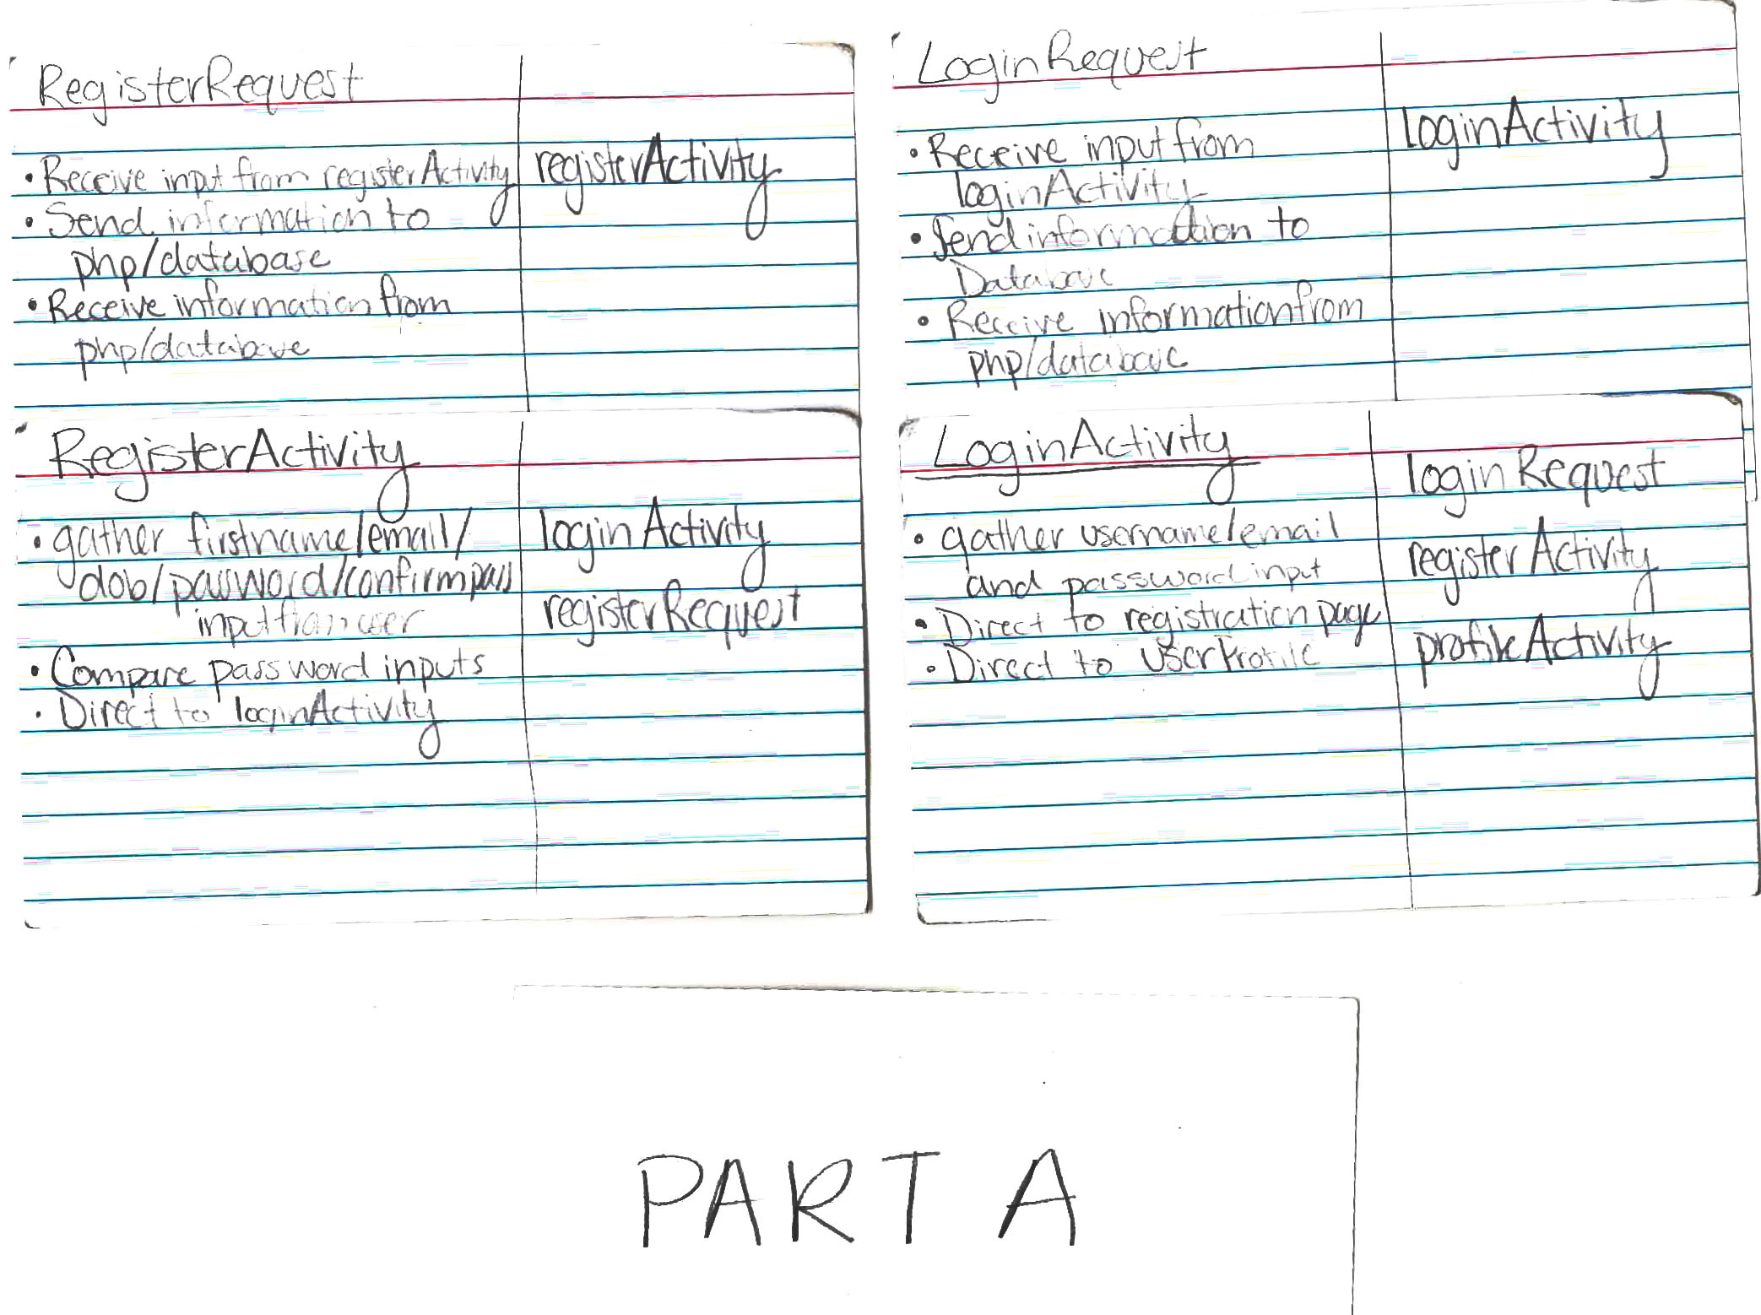

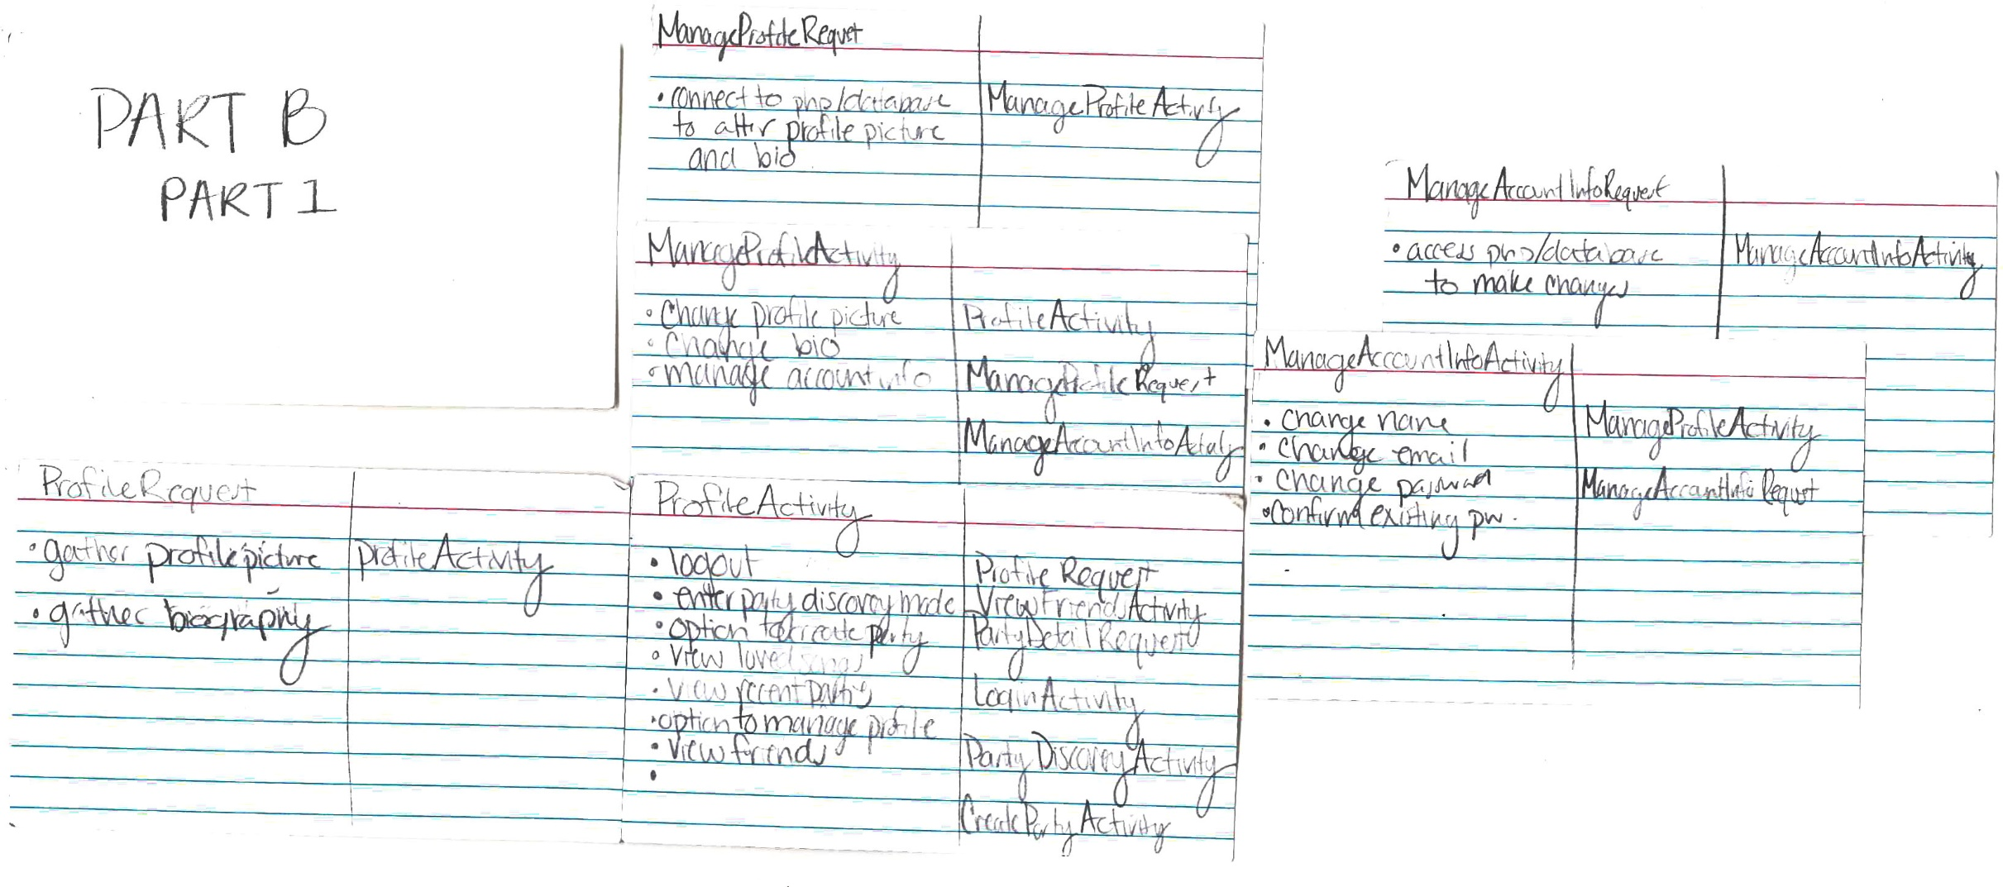

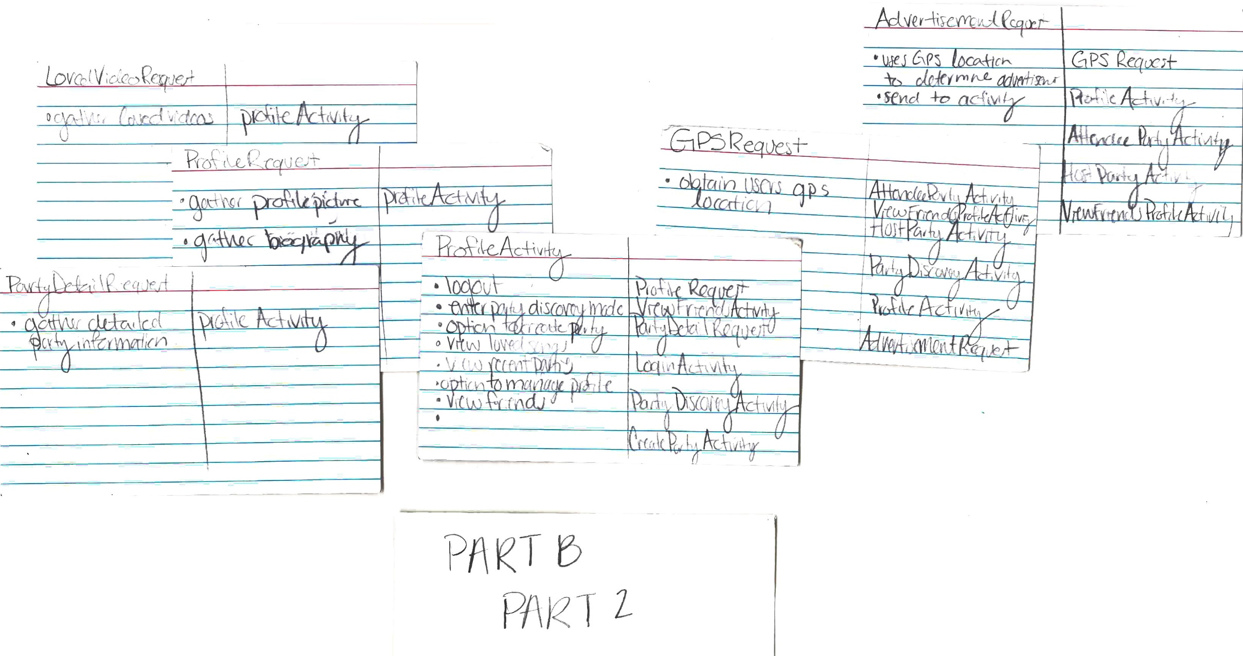

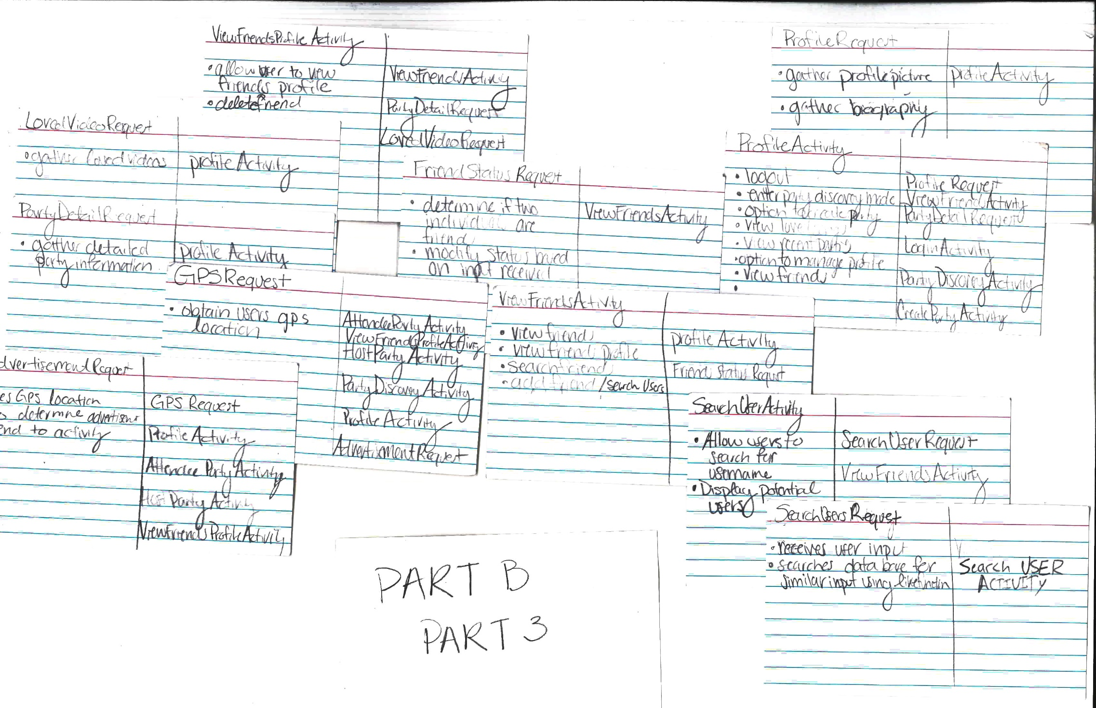

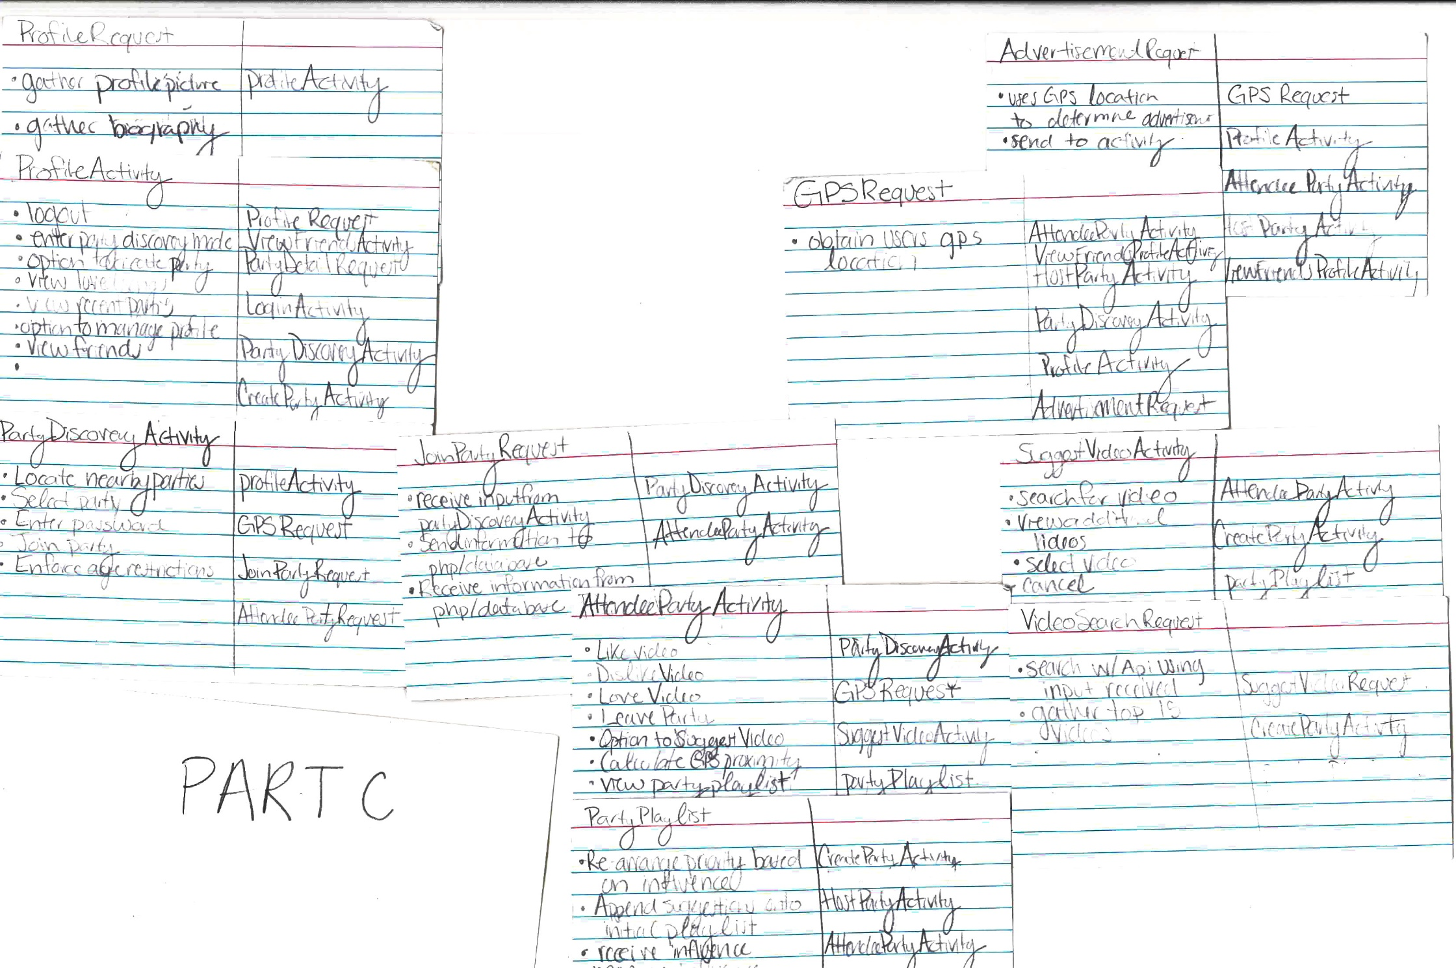

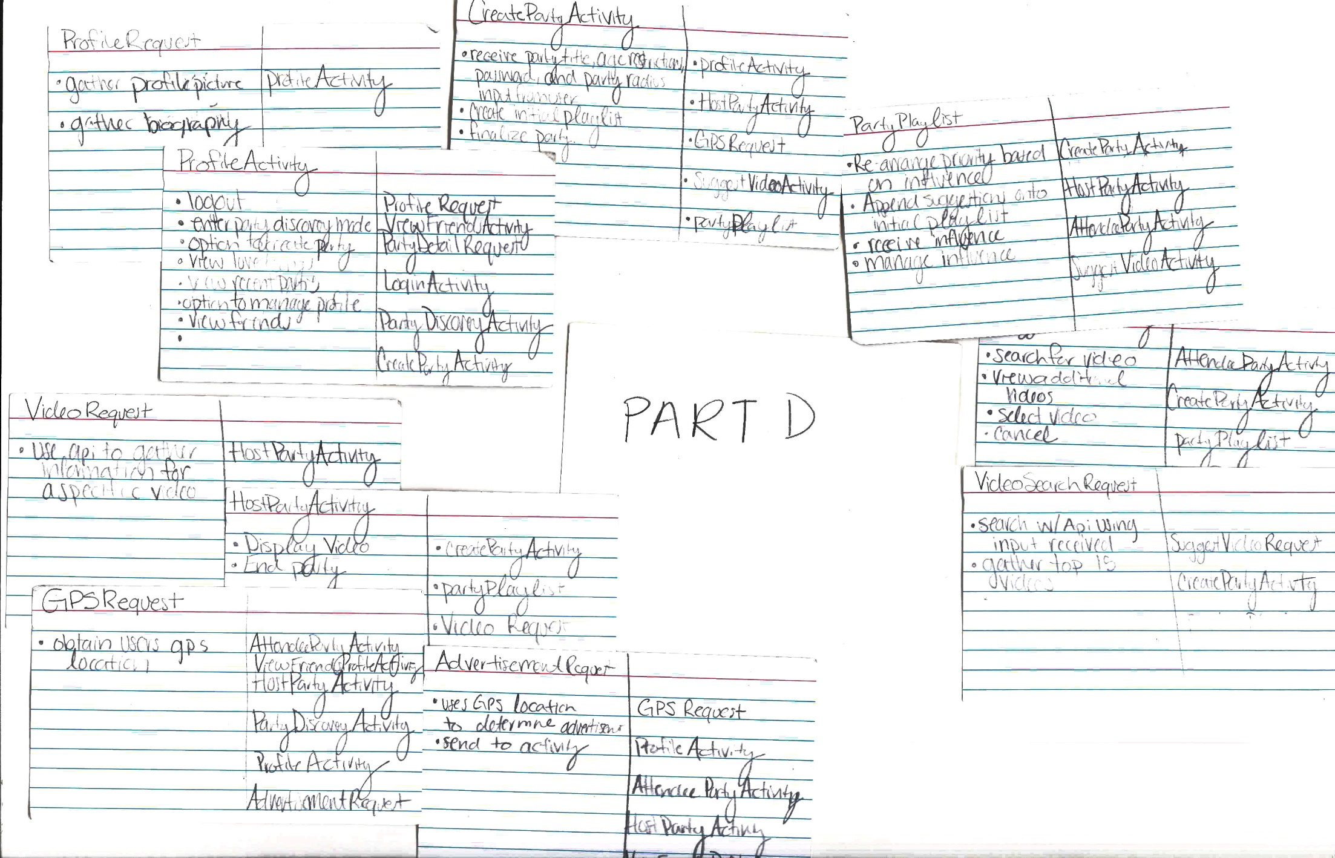

Appendix B: ERD

PartyID

Name

Age

Radius

Password

Playlist

Stored Songs

PartyLog

1:N

1:N

**Party**

List of Songs

**Stored Songs**

1:N

**Receive**

**Party Log**

List of Parties

Date

1:N

**Has**

List of Music

**User**

UserID

name

dob

email*

role

LoginInfo

Friends

1:1

ProfileID

UserID

Picture

LoginInfo

Friends

Party Log

Stored Songs

**Profile**

**Create**

**Login Info**

**Friends**

List

Username

Password

1:1

1:1

**Create**

**Playlist**

1:1

Appendix C: Flow of Activities

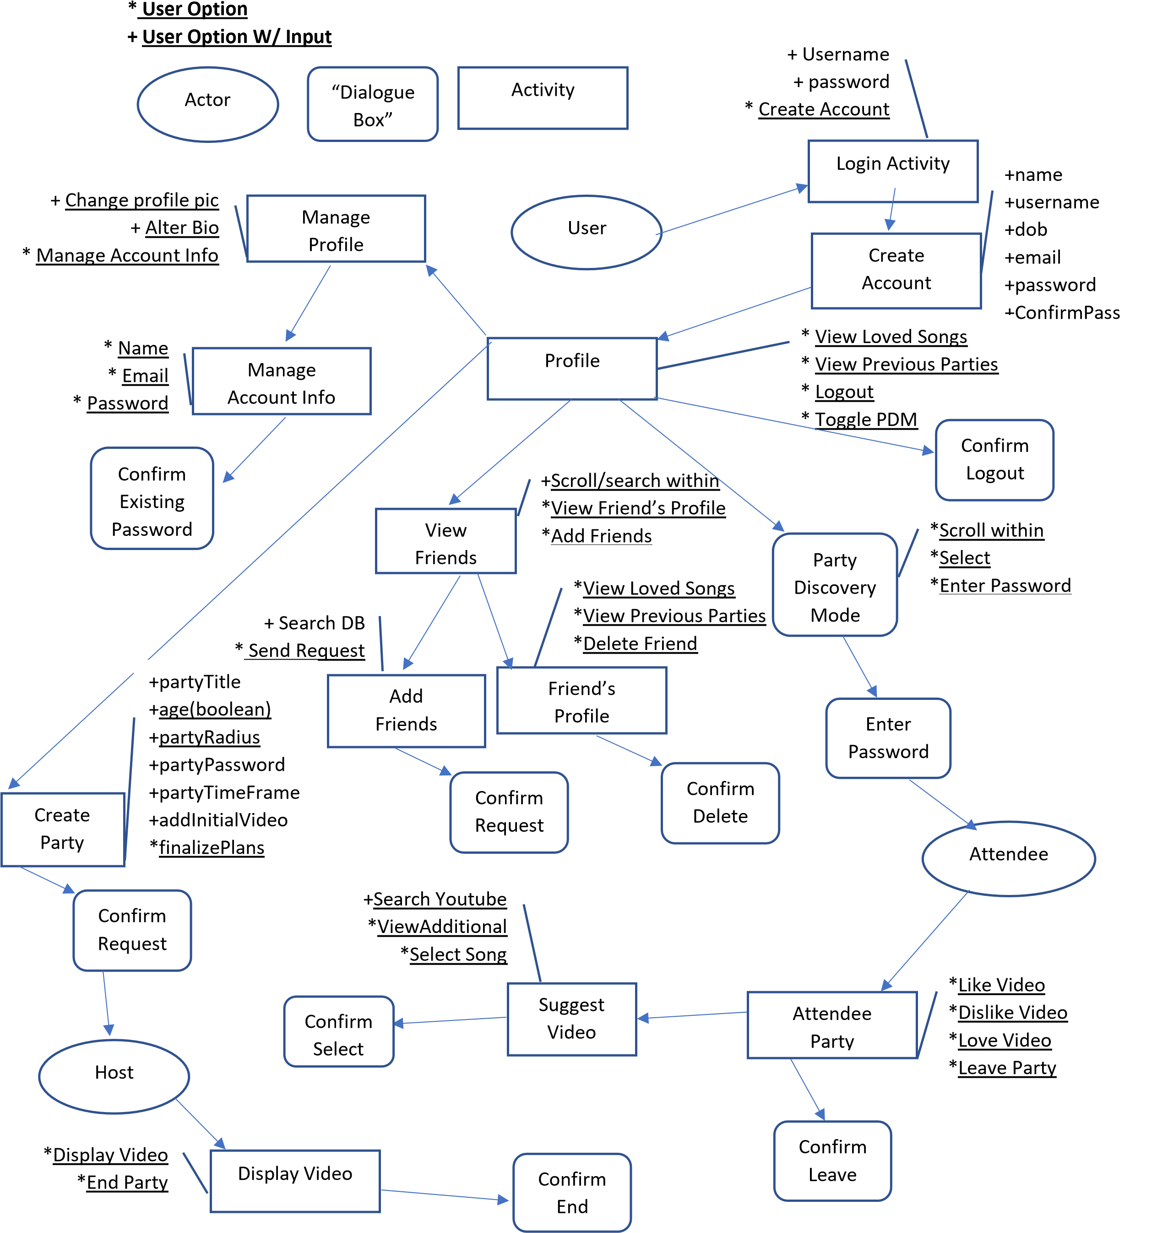 **+ User Input**

Appendix C: Low-Fidelity Mockups

**Create Account**

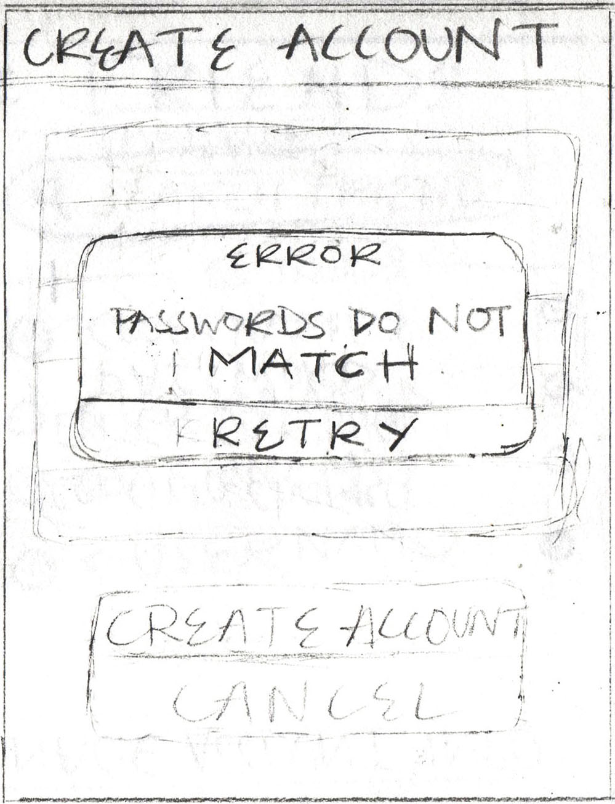

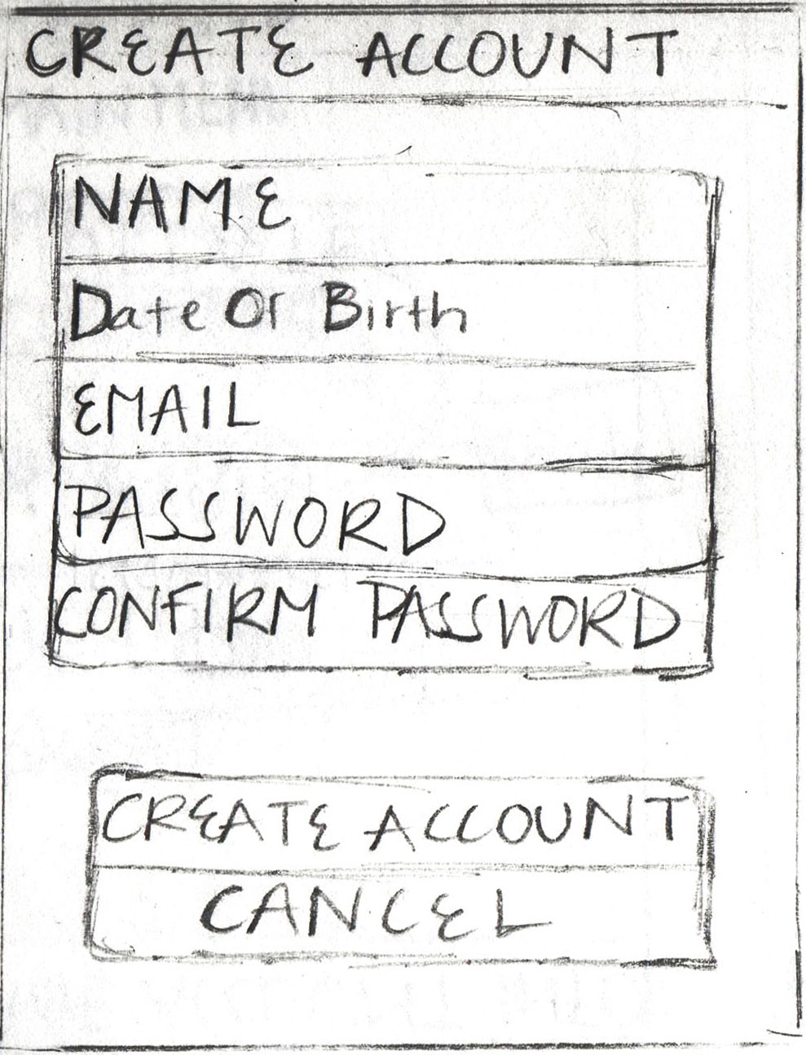

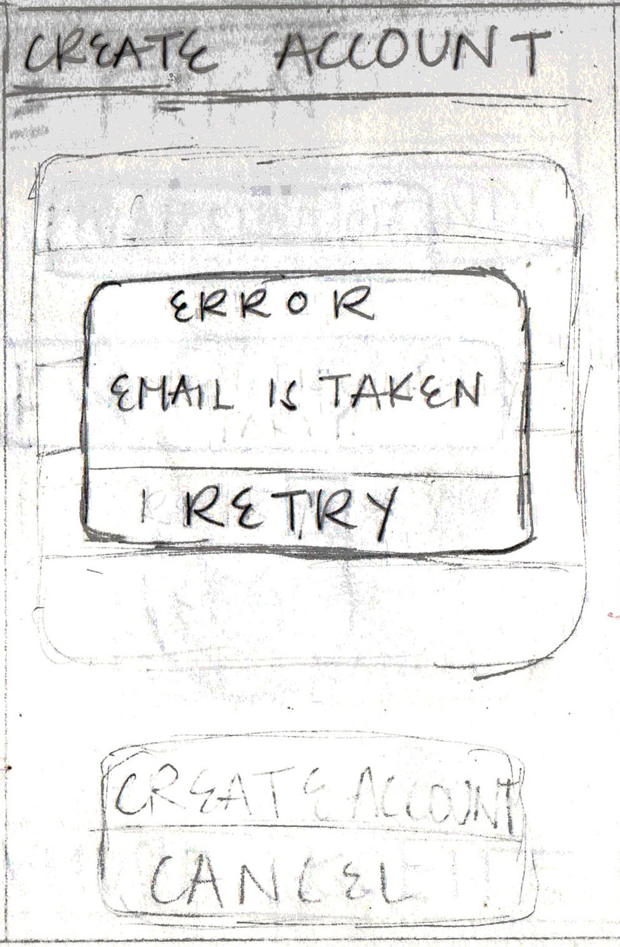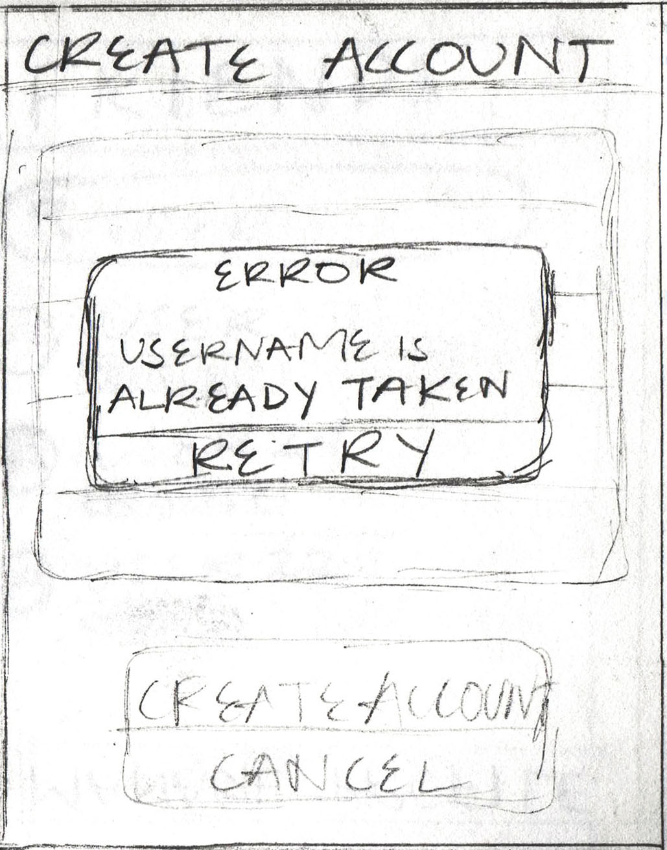

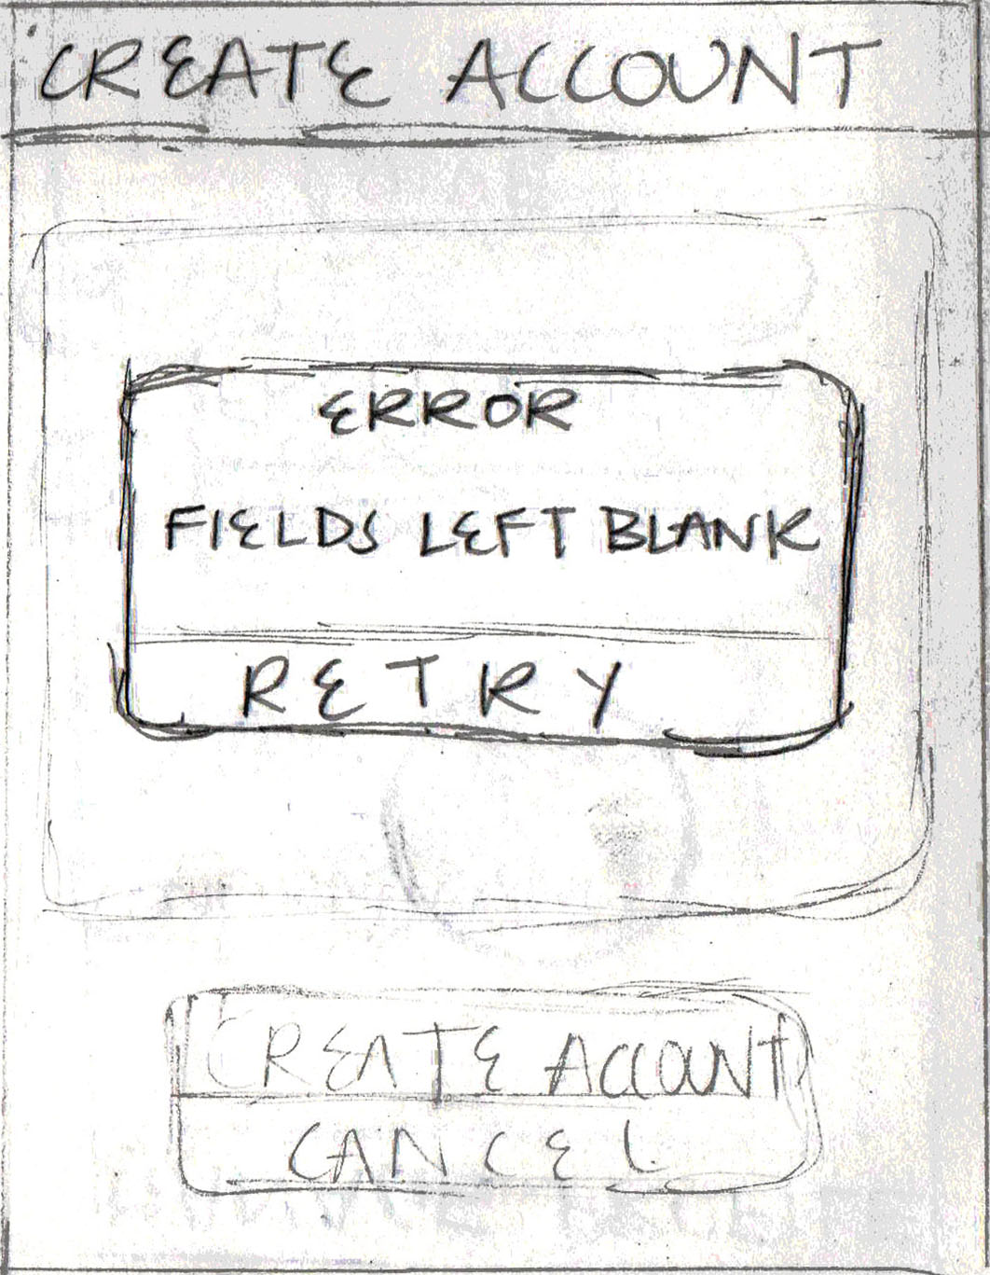

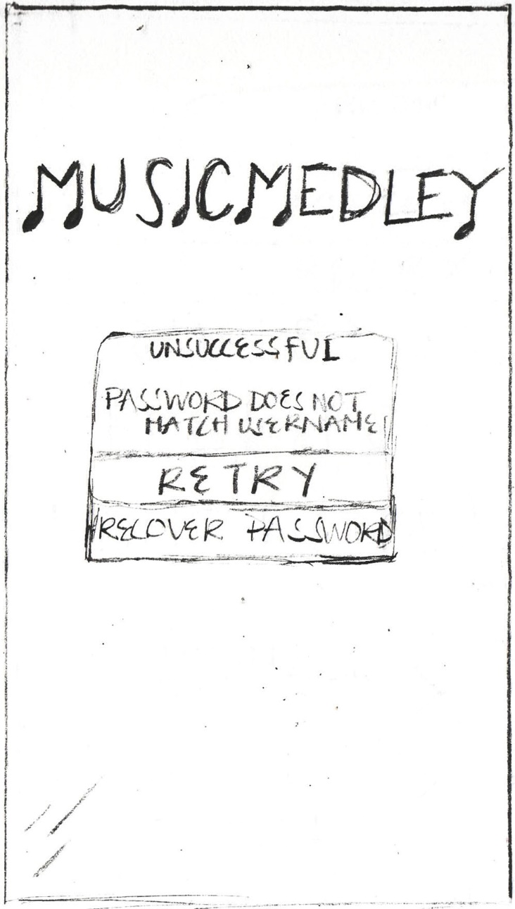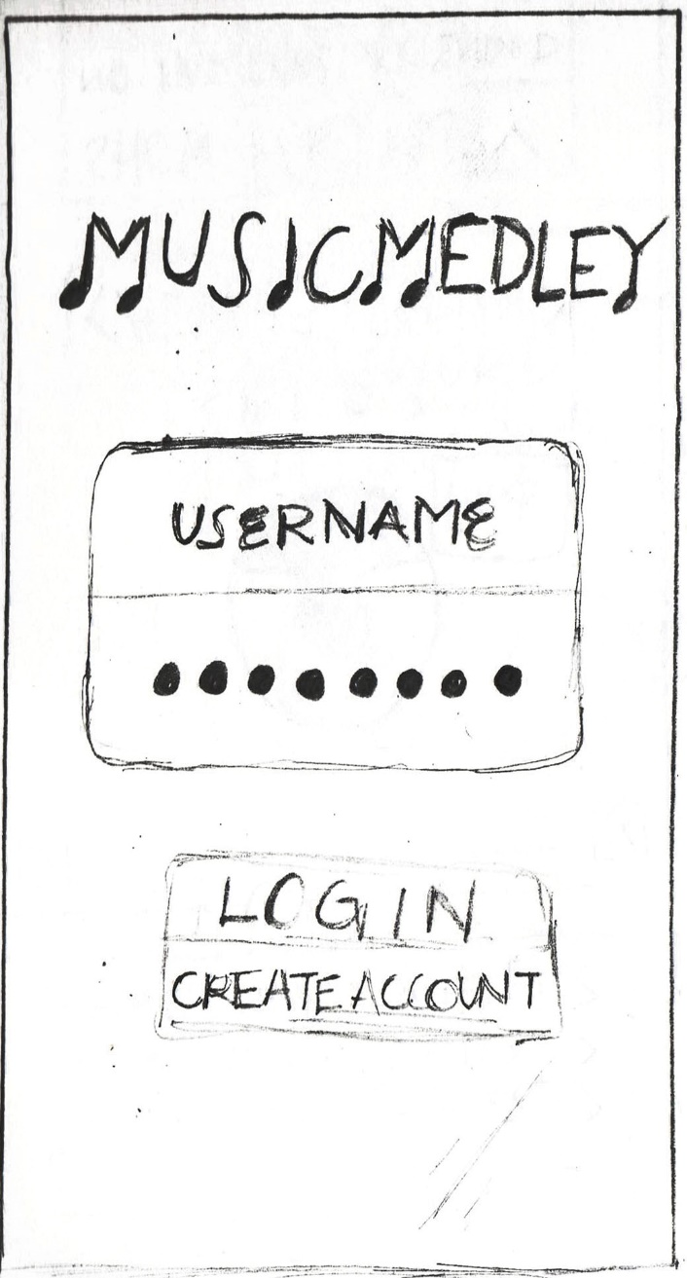**Login**

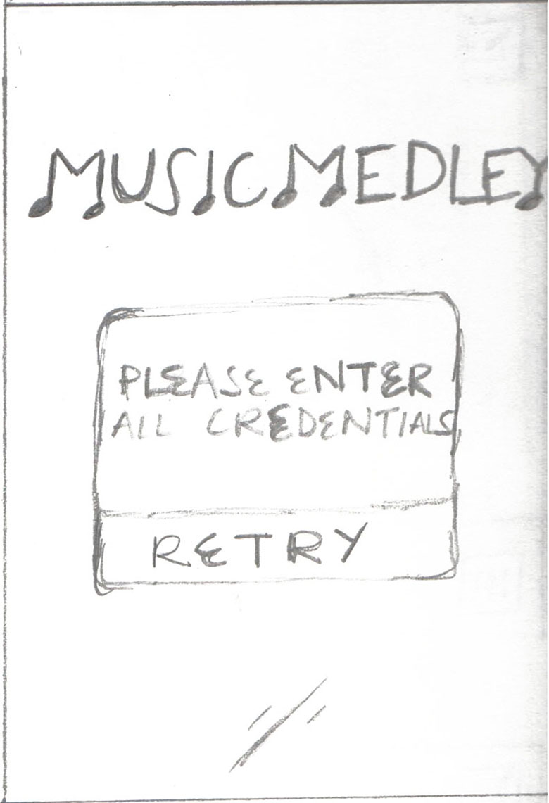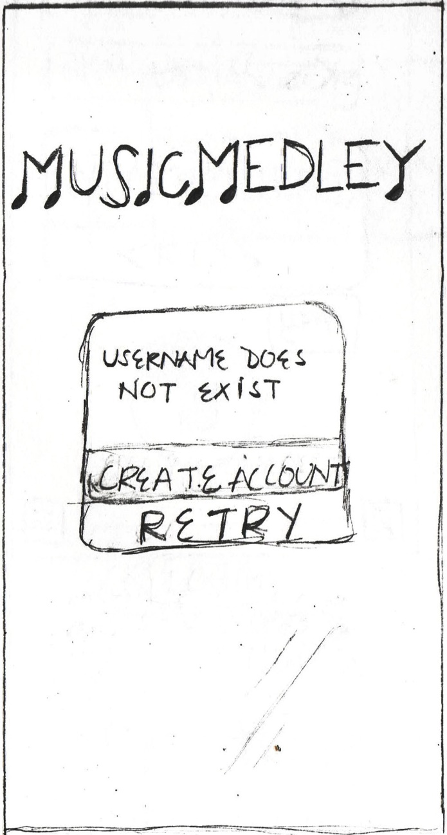

**Profile Activity**

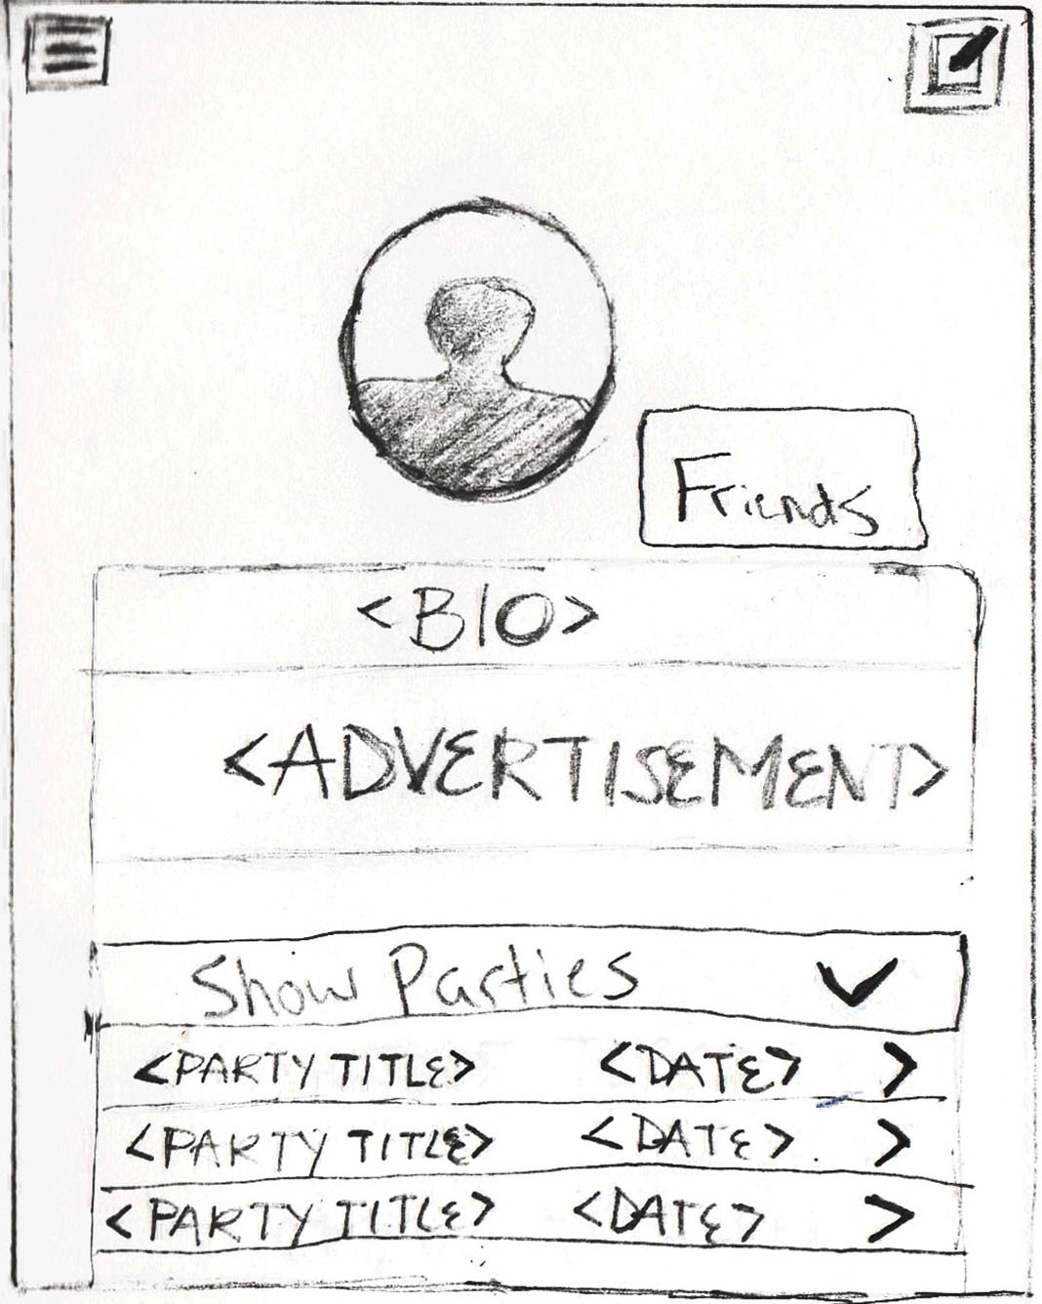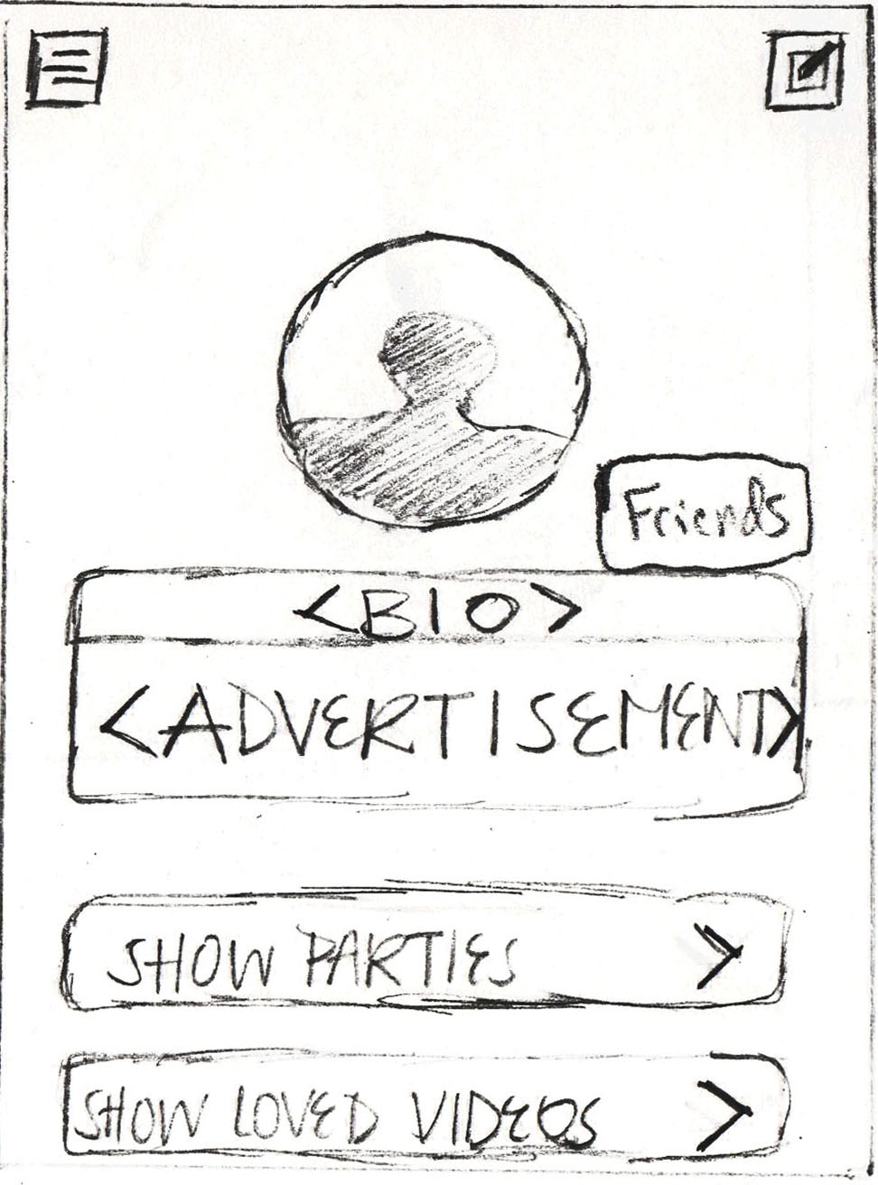

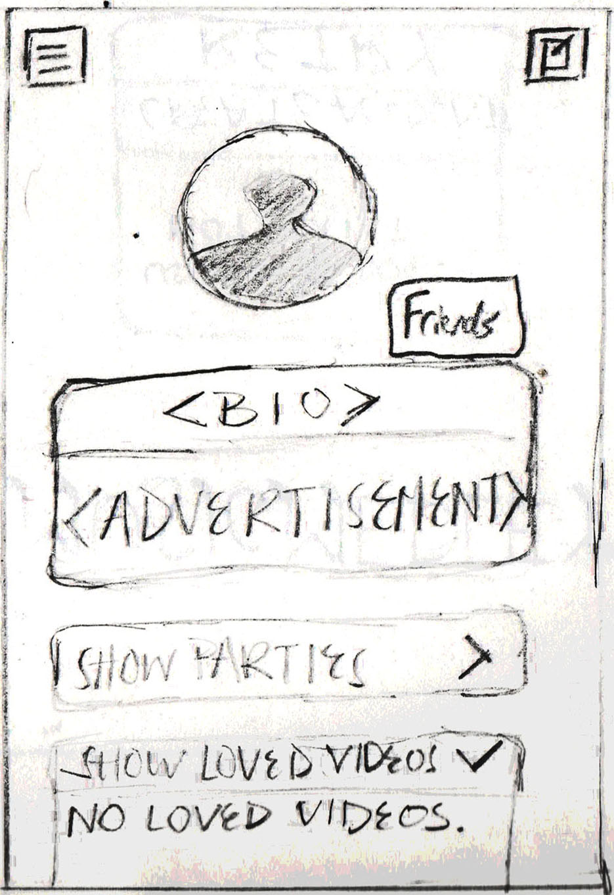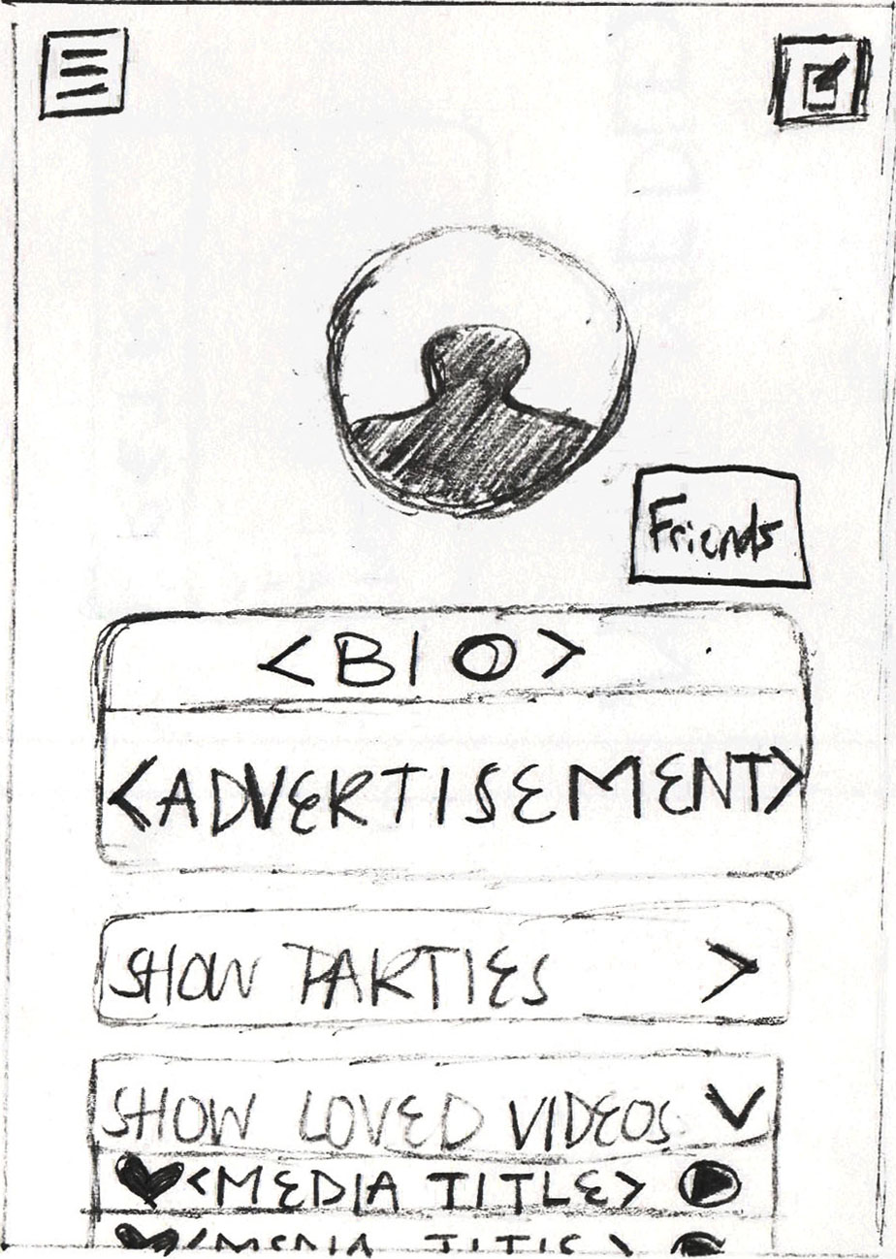

**Manage Profile**

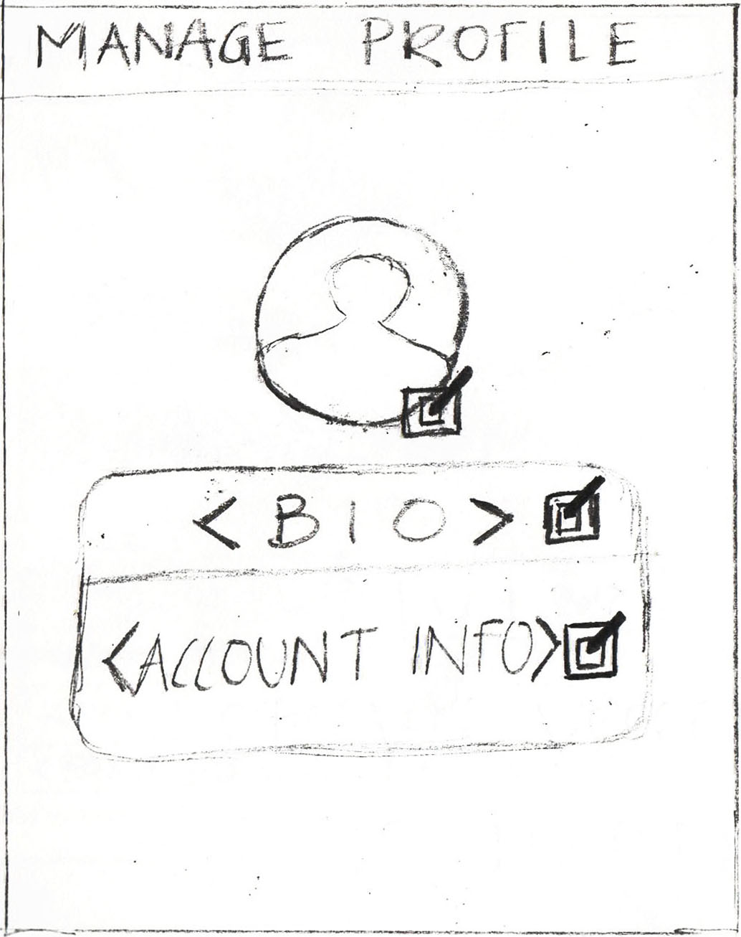

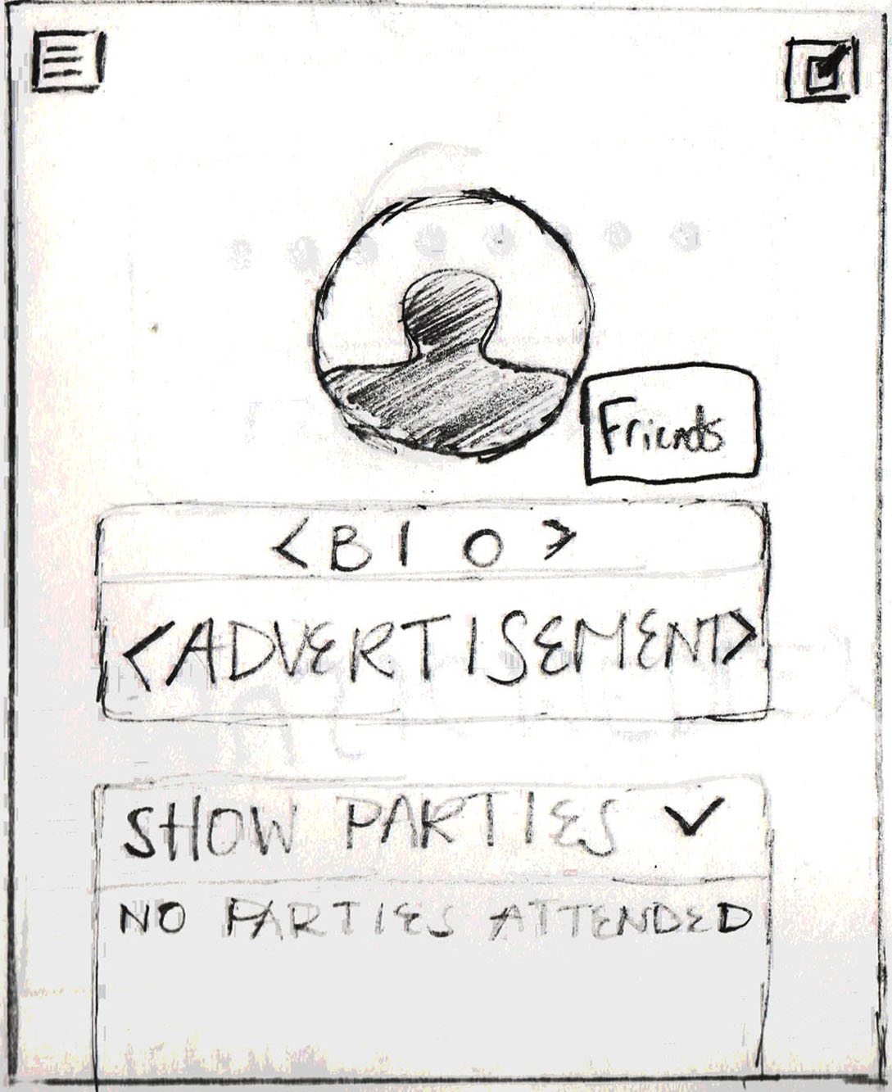

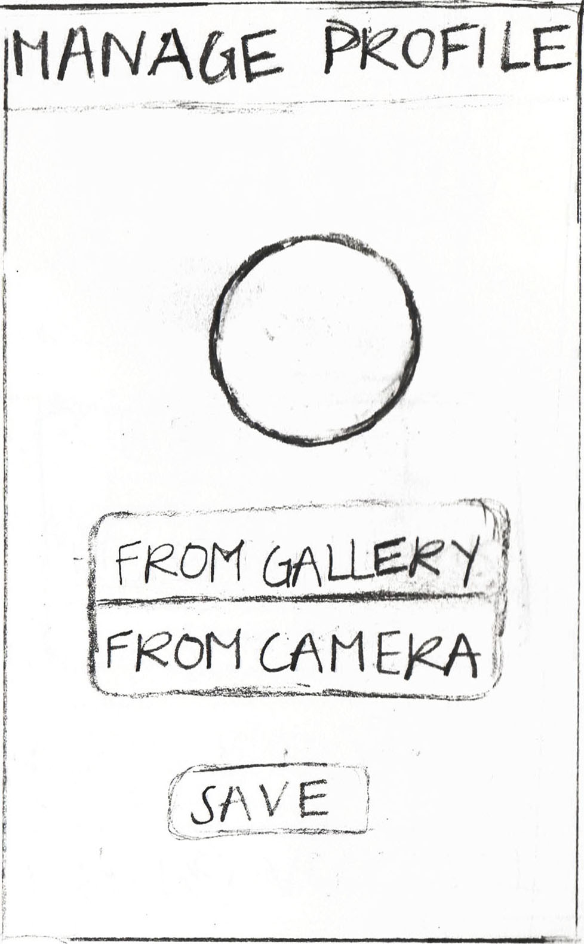

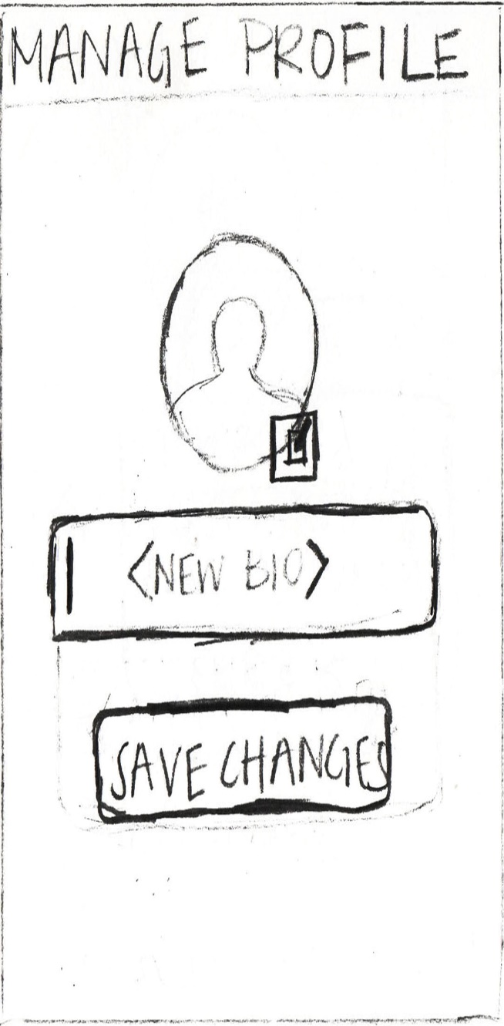

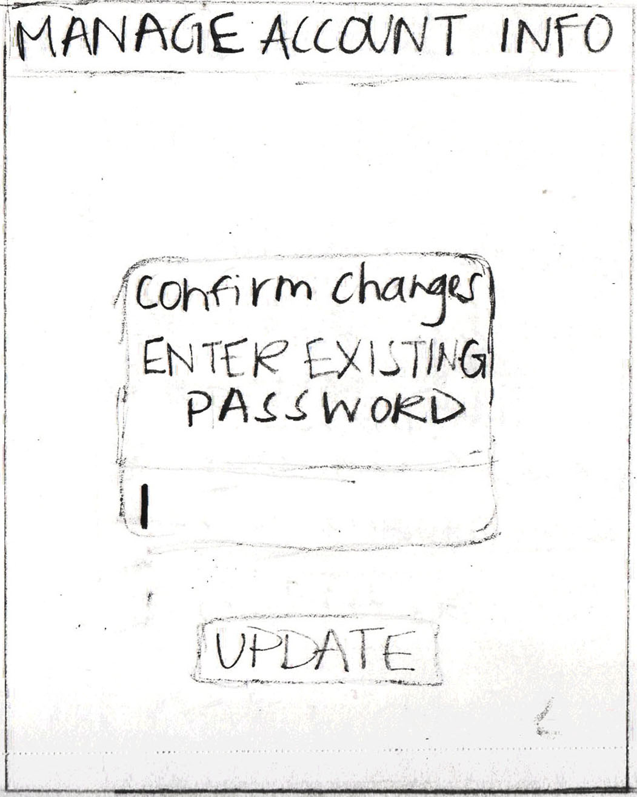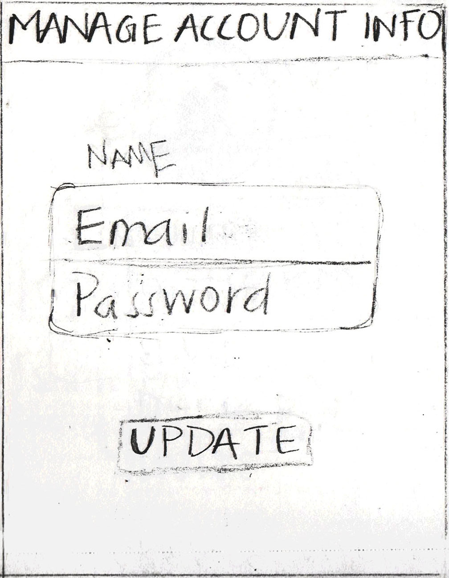

**Hamburger Menu**

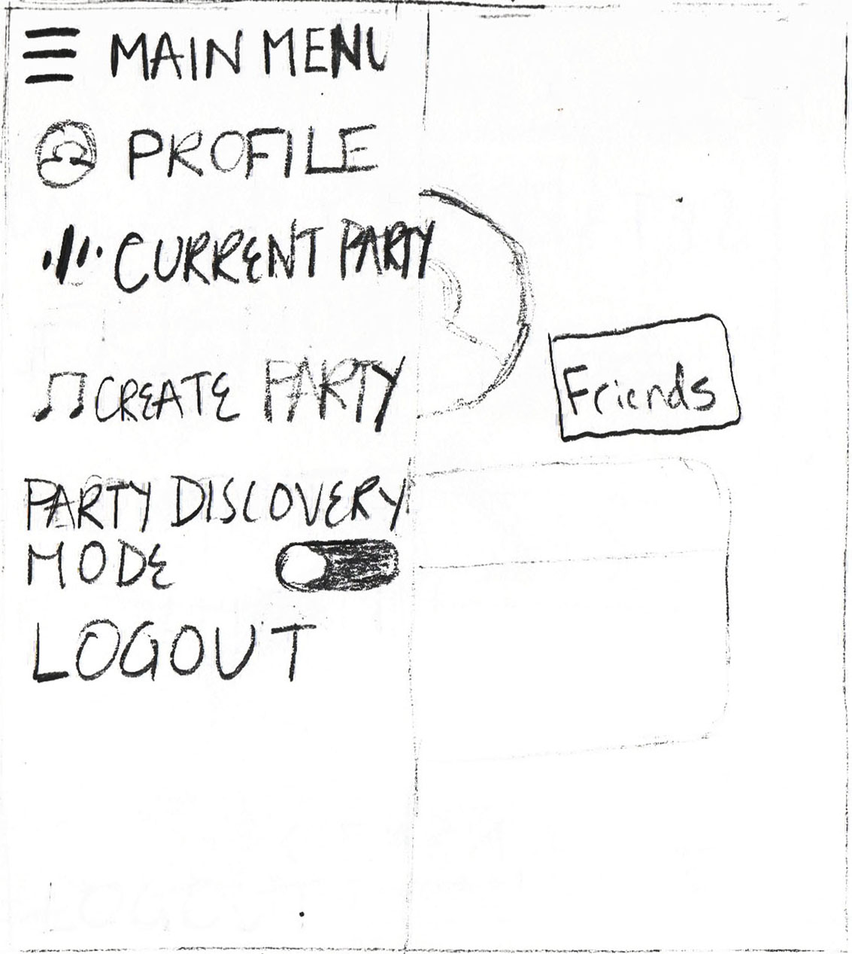

**Friends**

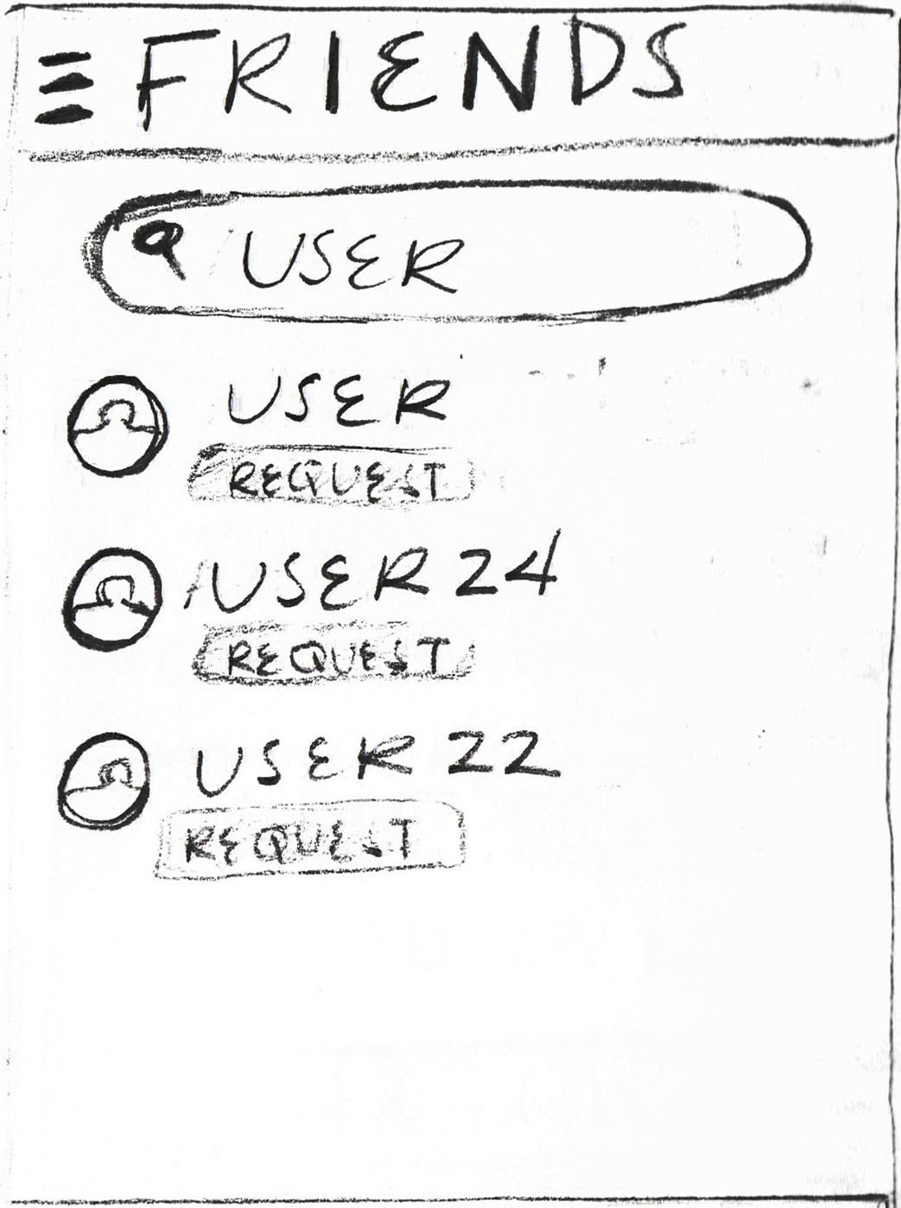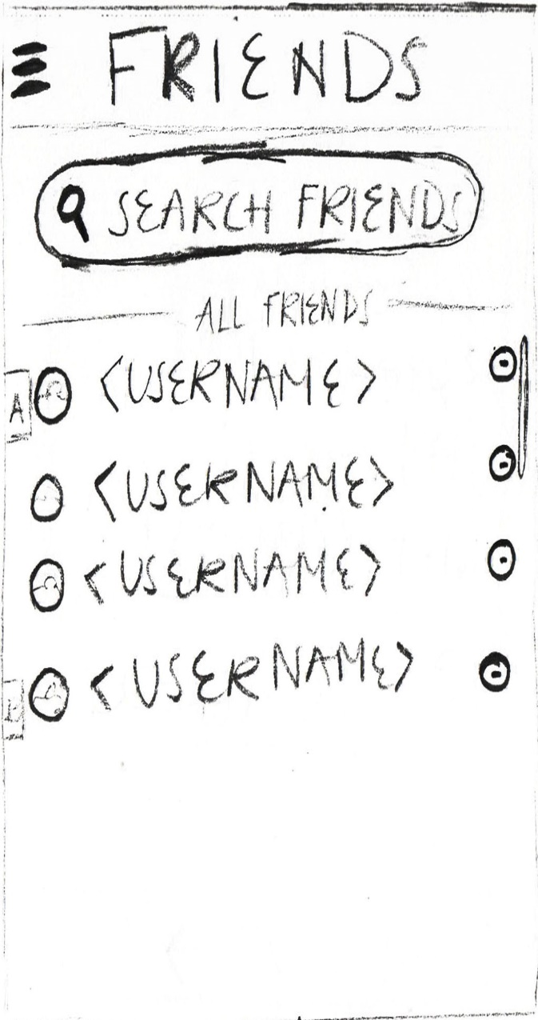

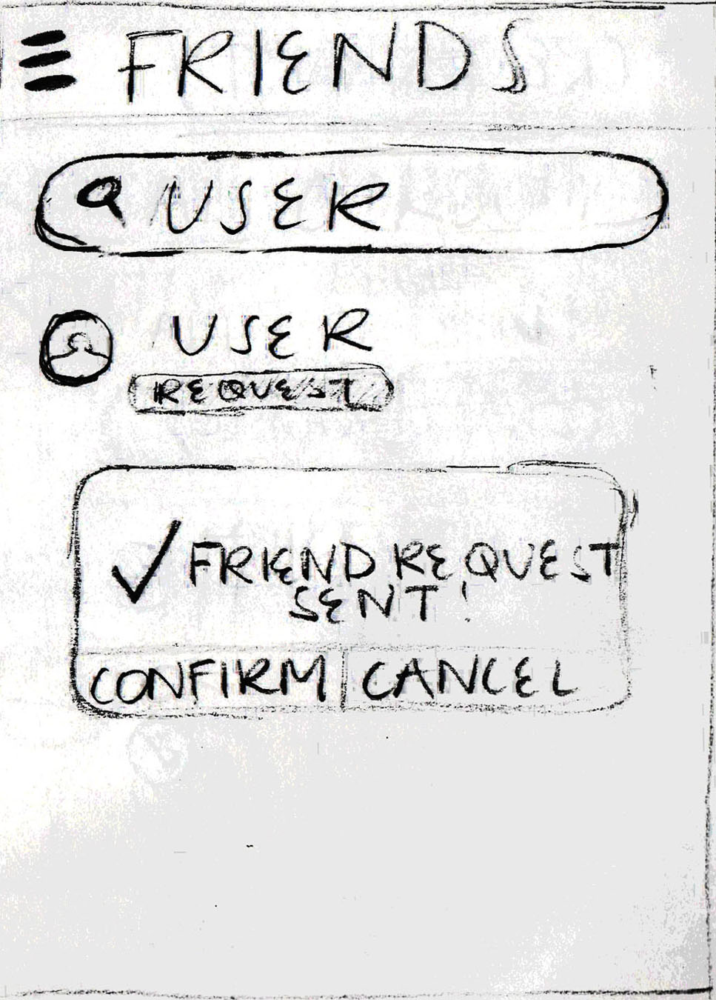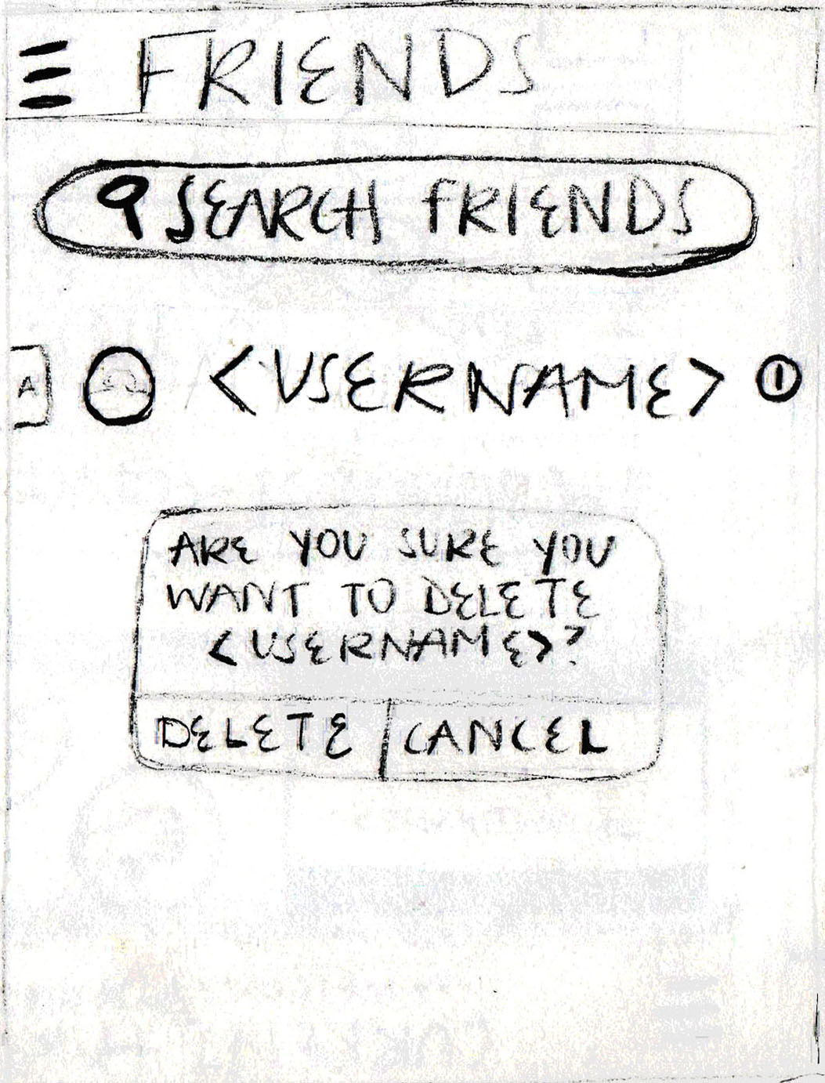

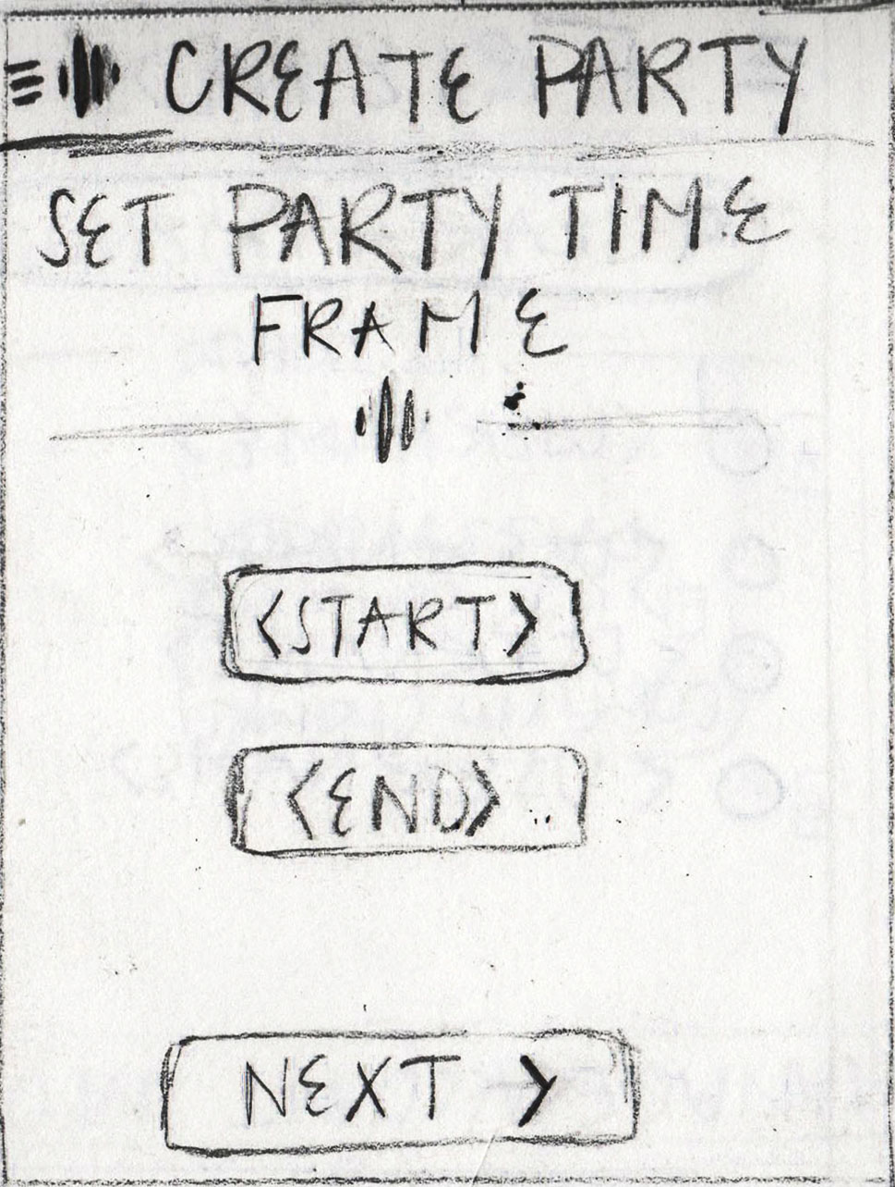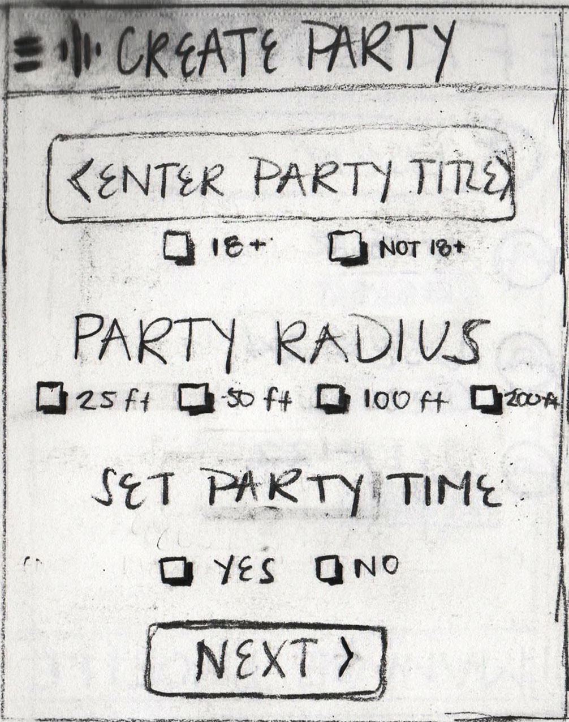**Create Party**

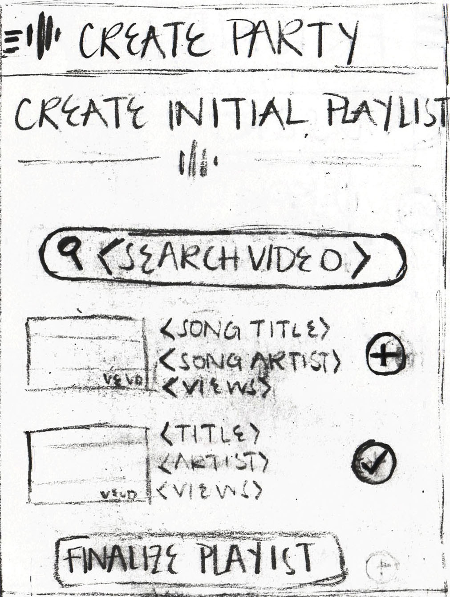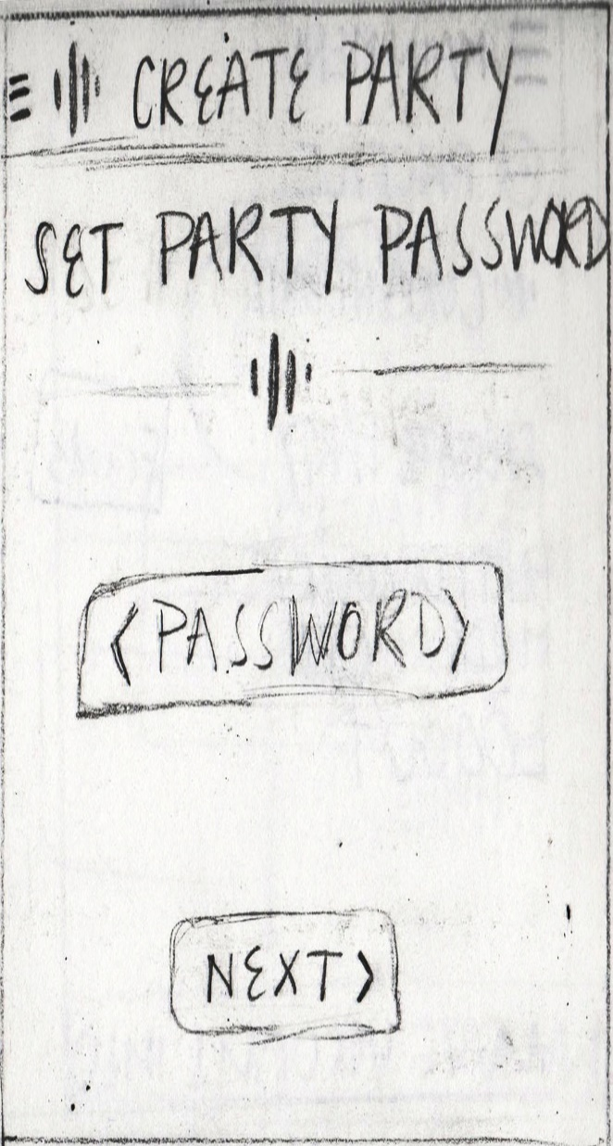

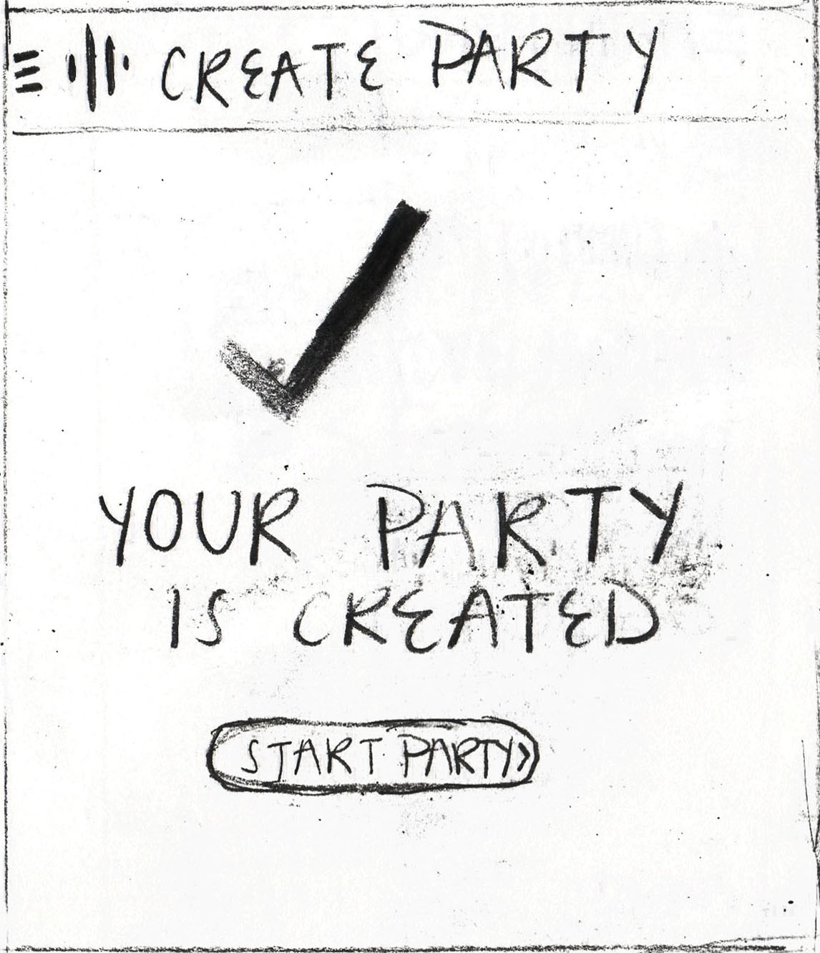

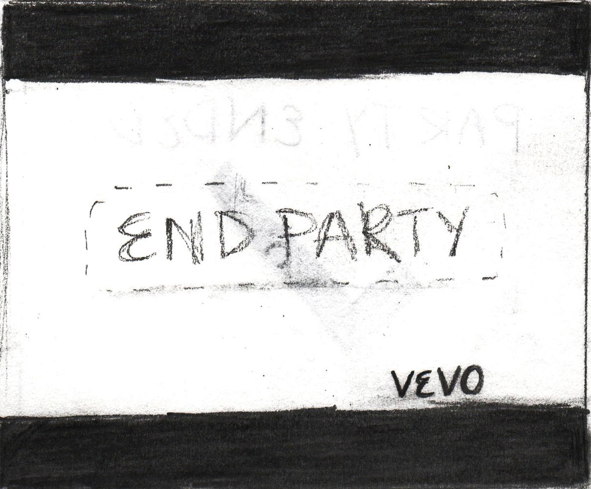**Host Playlist**

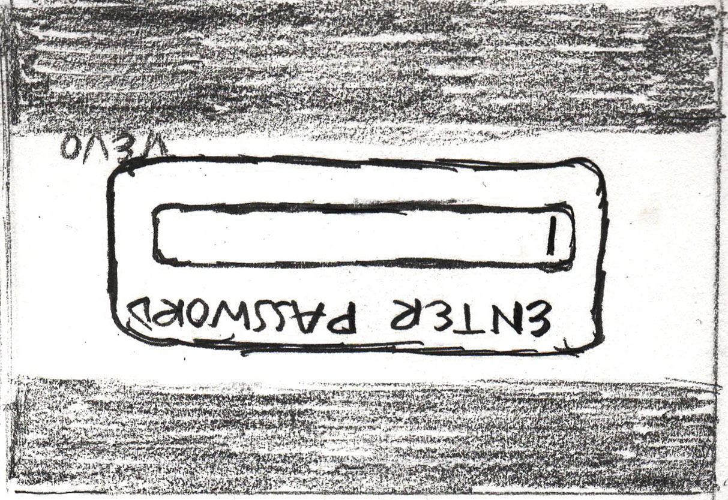

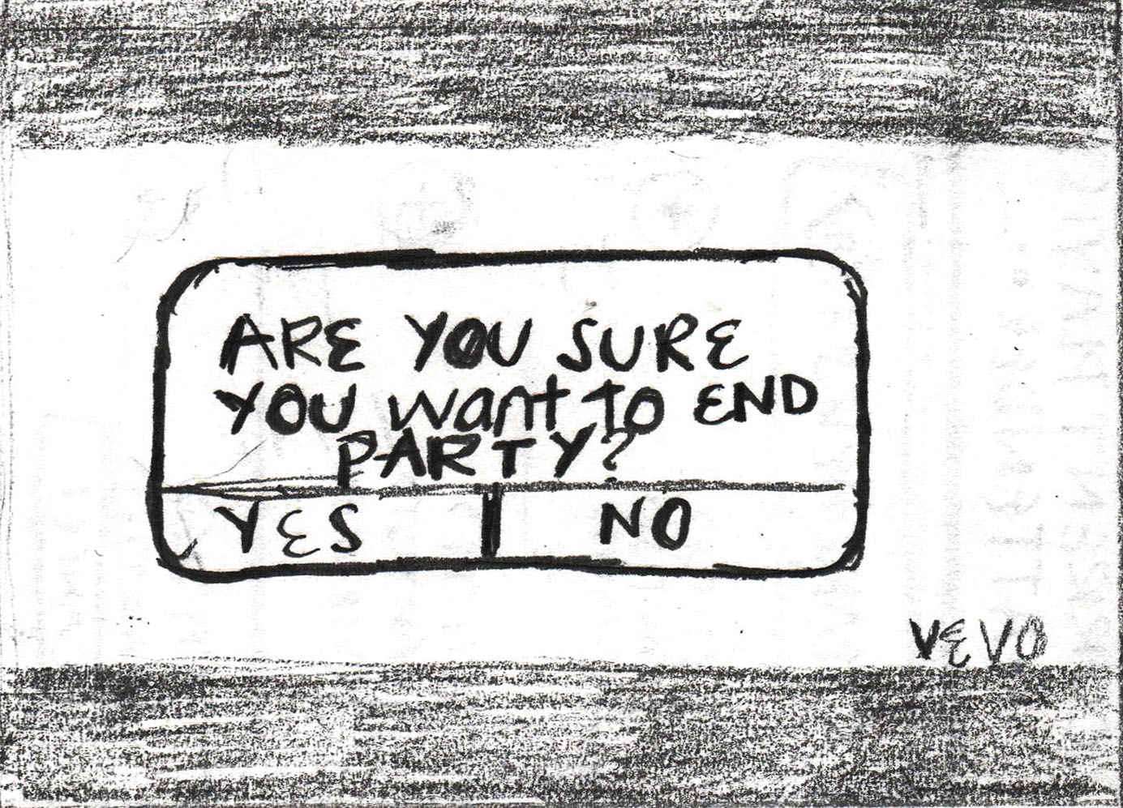

**Party Discovery Mode**

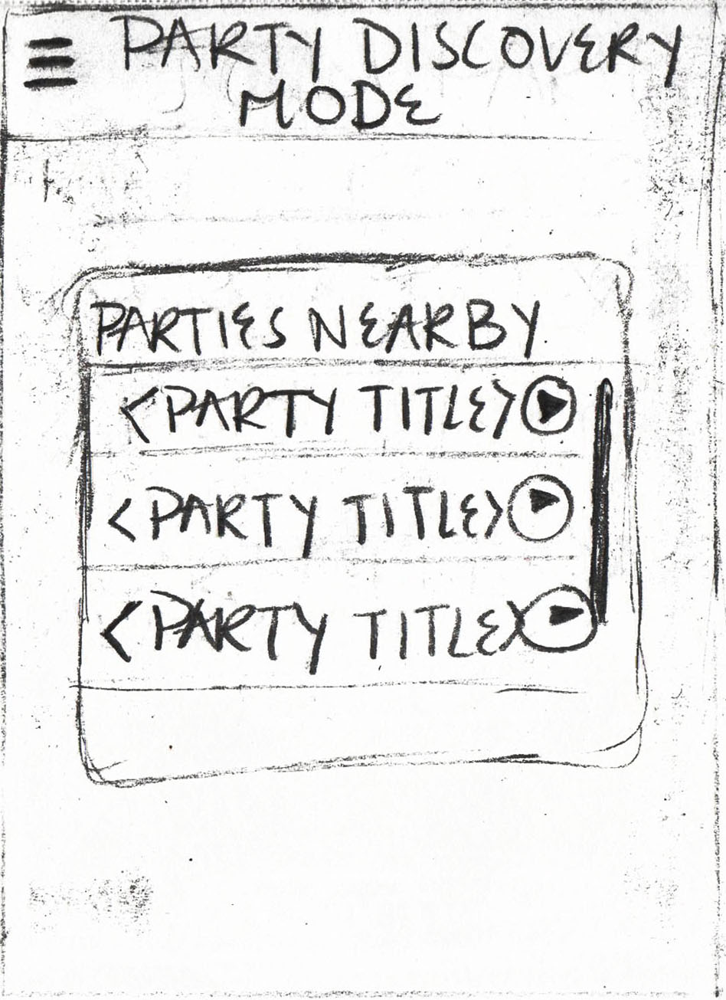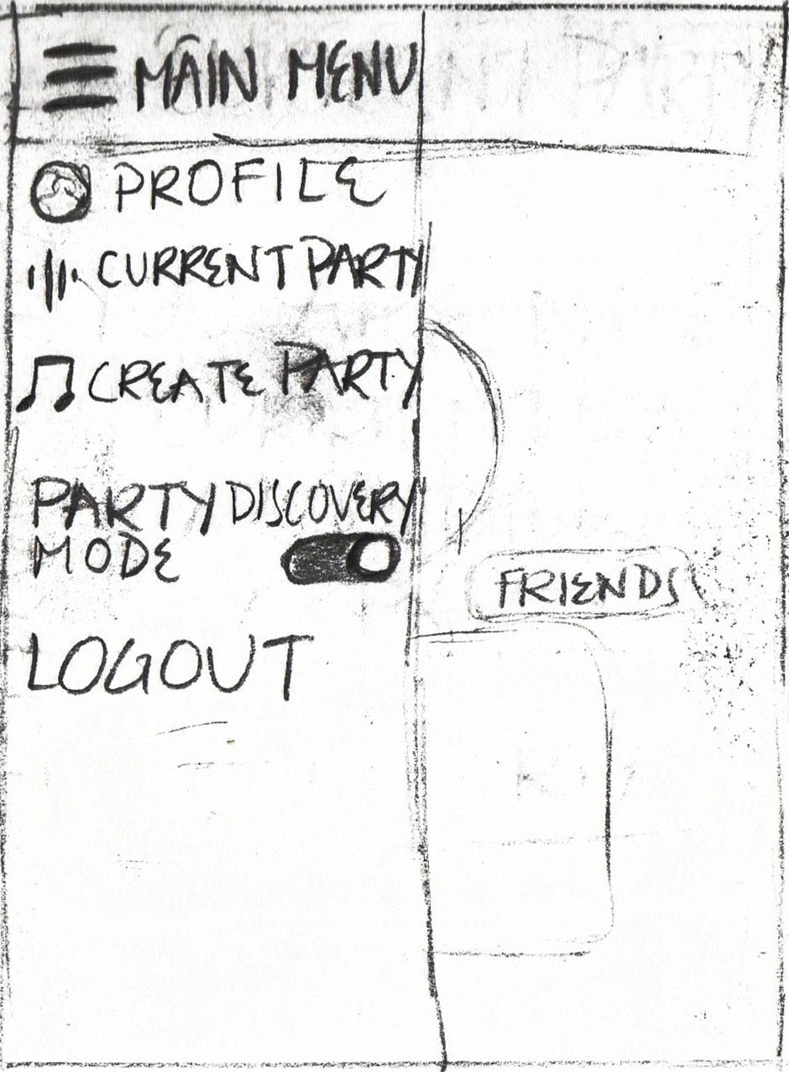

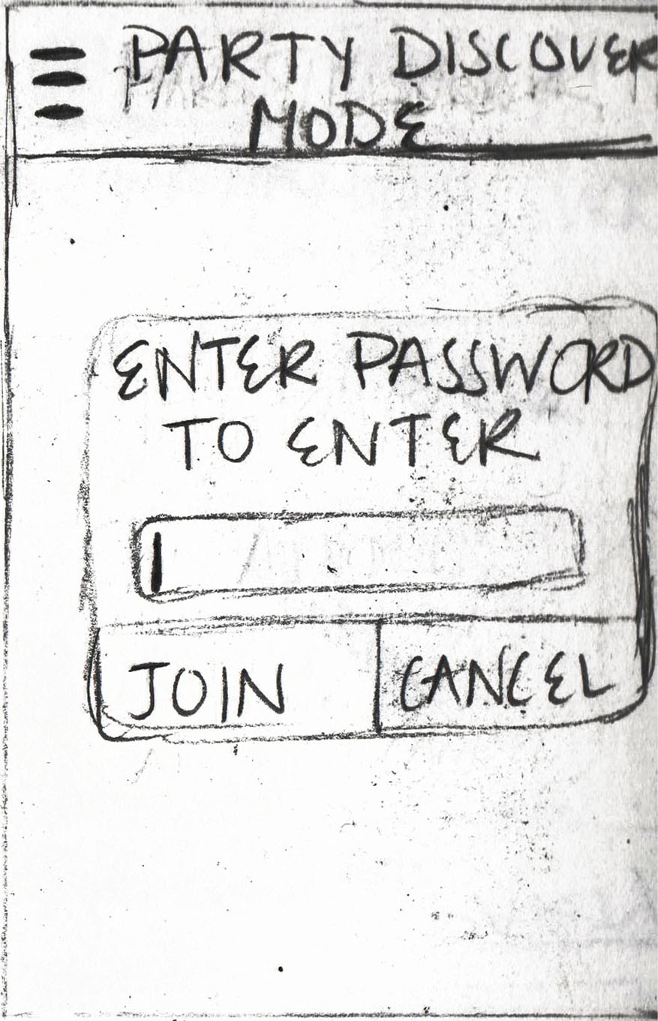

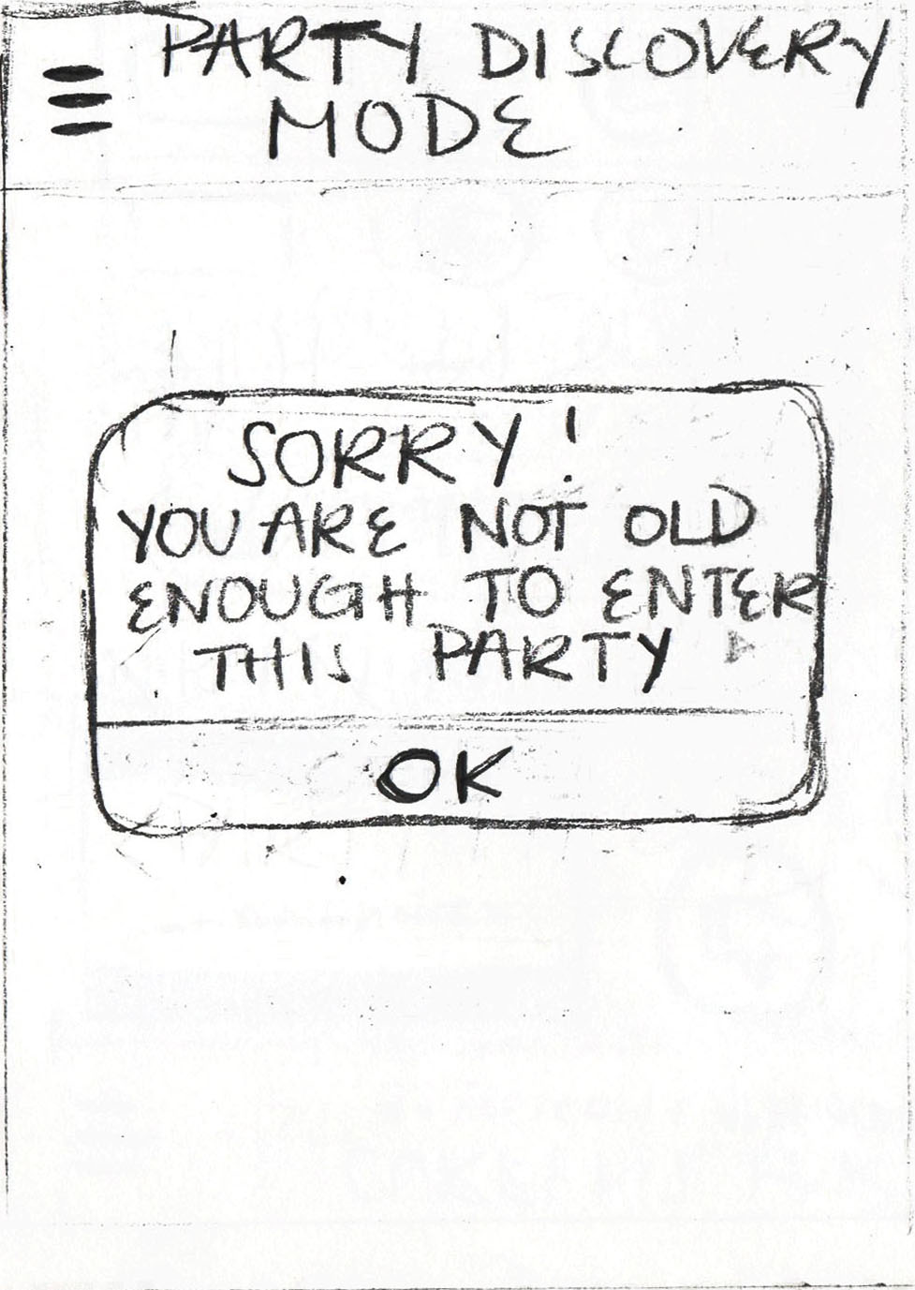

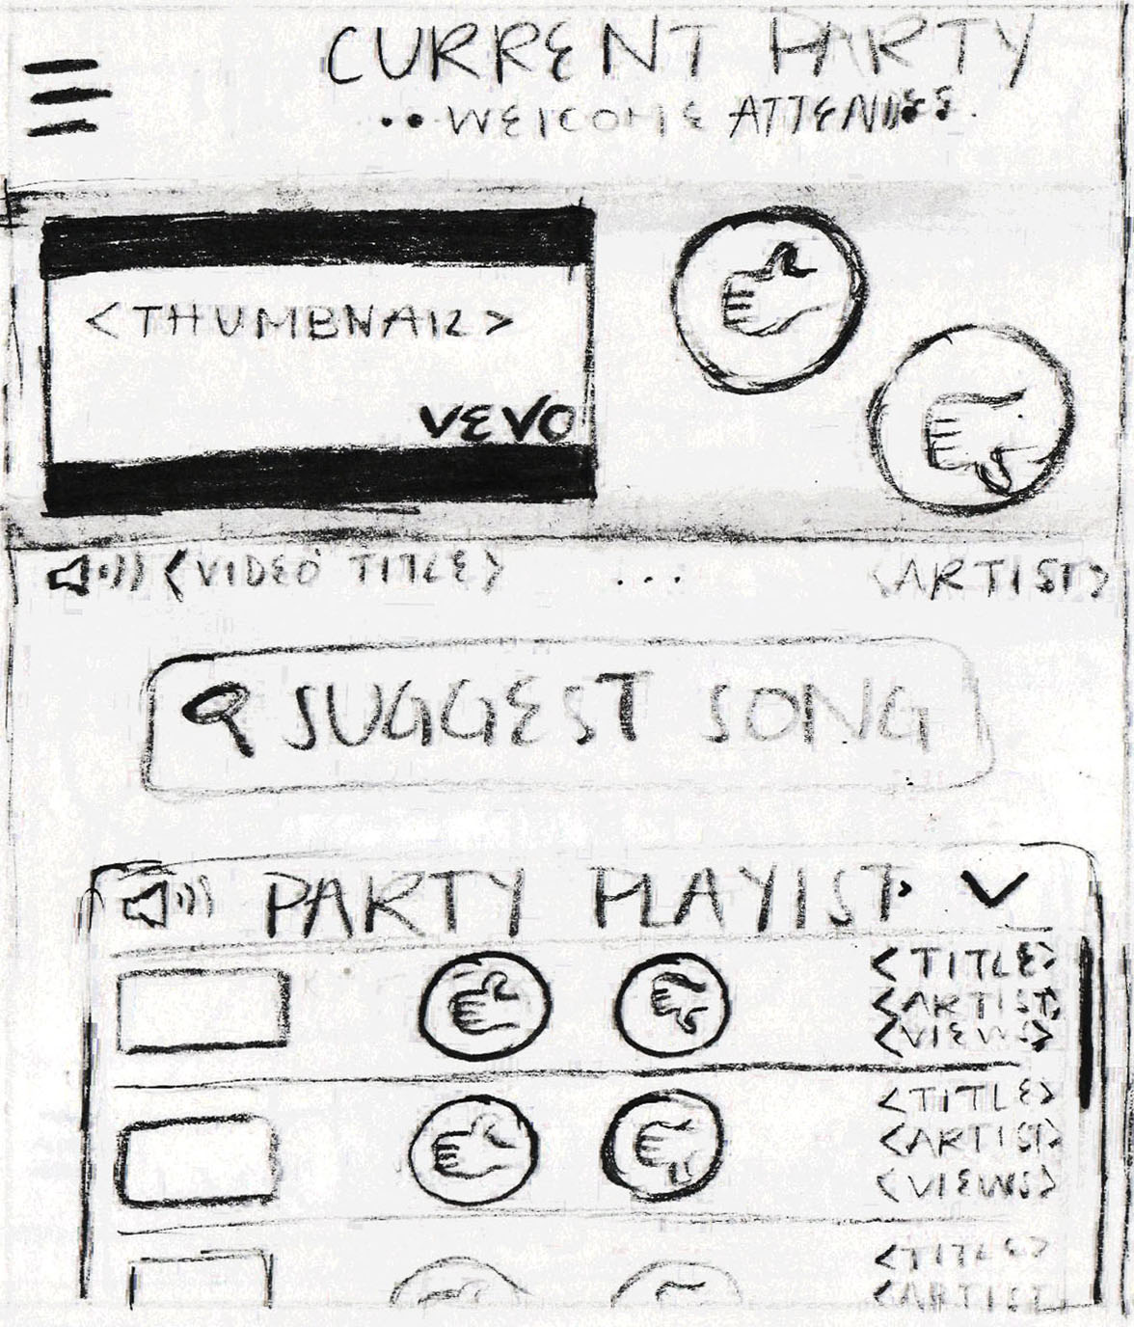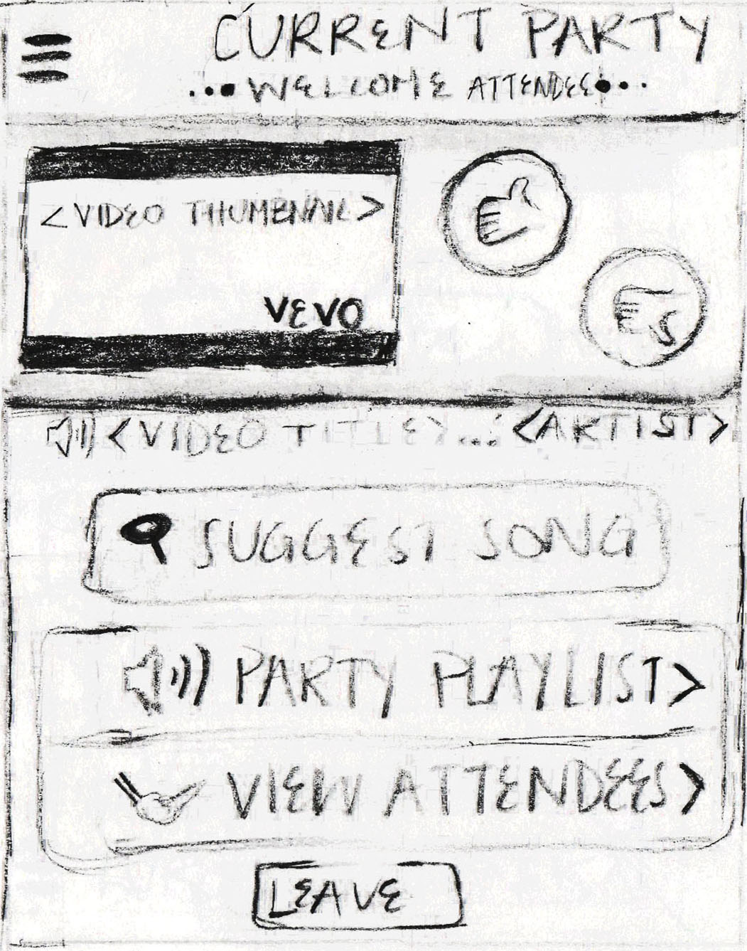**Attendee Party**

